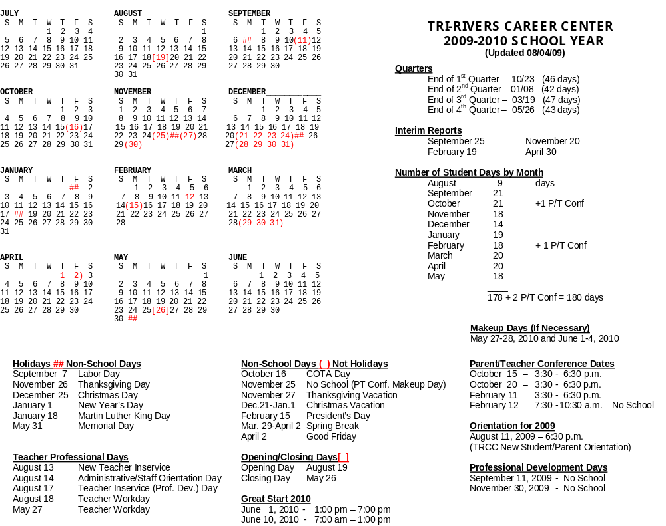
GENERAL STAFF INFORMATION

Tri-Rivers Career Center
School Calendar 2009-2010

August 13 New Staff In-Service
August 14 Admin./Staff Orientation Day
August 17 Teacher In-Service
August 18 Staff Work Day
August 19 First School Day for New Students
August 20 First School Day for Returning Students
September 7 Labor Day (No Classes)
September 11 Professional Development Day – No School
October 15 Parent/Teacher Conferences (3:30-6:30 p.m.)
October 16 Waiver Day/Professional Development (No Classes)
October 20 Parent/Teacher Conferences (3:30-6:30 p.m.)
October 23 End of 1st Quarter (46 Days)
November 25 - 27 Thanksgiving Recess
November 30 Professional Development Day – No School
December 21-January 1 Christmas & New Year’s Recess
January 4 School Resumes
January 8 End of 1st Semester & 2nd Qtr. (42 Days)
January 18 Martin Luther King Day (No Classes)
February 11 Parent/Teacher Conferences (3:30-6:30 p.m.)
February 12 Parent/Teacher Conferences (7:30-10:30 a.m.)
February 12 (No Classes)
February 15 President’s Day (No Classes)
March 19 End of 3rd Quarter (47 Days)
March 29-April 2 Spring Recess (No Classes)
April 2 Good Friday (No Classes)
May 26 End of 4th Qtr. & 2nd Semester (43 Days)
May 26 Last Day for Students
May 27 Staff Work Day
May 30 Memorial Day (No Classes)

Nine-week grading periods will end on the following dates:

1. October 23 46 Days
2. January 8 42 Days
3. March 19 47 Days
4. May 27 43 Days
Total 178 Days

CHARACTER EDUCATION – MONTHLY TOPICS
2009-2010 SCHOOL YEAR

MONTH | CHARACTER TOPIC
SEPTEMBER 2009 | Respect
OCTOBER 2009 | Tolerance
NOVEMBER 2009 | Citizenship
DECEMBER 2009 | Leadership
JANUARY 2010 | Attitude
FEBRUARY 2010 | Caring
MARCH 2010 | Responsibility
APRIL 2010 | Role Model
MAY 2010 | Fairness

Note: Each Career-Technical instructor and each academic discipline group (English, Math, Science, Social Studies) are expected to submit a student name for recognition on a monthly basis.

BELL SCHEDULE
2009-2010

MONDAY TUESDAY - FRIDAY

Music 8:14 – 8:18 Music 8:14 – 8:18
1 8:18 – 8:53 1 8:18 – 9:03
2 8:57 – 9:30 2 9:07 – 9:47
3 9:34 – 10:07 3 9:51 – 10:31
4 10:11 – 10:41 4 10:35 – 11:05
5 10:45 – 10:48 5 11:09 – 11:15
6 10:52 – 11:22 6 11:19 – 11:49
7 11:26 – 11:29 7 11:53 – 11:59
8 11:33 – 12:03 8 12:03 – 12:33
9 12:07 – 12:40 9 12:37 – 1:17
10 12:44 – 1:17 10 1:21 – 2:01
11 1:21 – 1:54 11 2:05 – 2:45
1:54 – 2:45 Success Period (1st & 3rd)
Student Prof. Dev. (2nd & 4th)

TWO HOUR DELAY TWO HOUR DELAY
(Monday) (Tuesday - Friday)

Music 10:14 – 10:18 Music 10:14 – 10:18
1 Eliminated 1 10:18 – 10:46
2 Eliminated 2 10:49 - 11:14
3 10:18 – 10:35 3 11:17 – 11:42
4 10:38 – 11:08 (1st. Lunch) 4 11:45 – 12:15 (1st Lunch)
5 Eliminated 5 Eliminated
6 11:11 – 11:41 (2nd. Lunch) 6 12:18 – 12:48 (2nd Lunch)
7 Eliminated 7 Eliminated
8 11:44 –12:14 (3rd. Lunch) 8 12:51 – 1:21 (3rd Lunch)
9 12:17 – 12:47 9 1:24 – 1:49
10 12:50 – 1:20 10 1:52 – 2:17
11 1:23 – 1:54 11 2:20 – 2:45
1:54 – 2:45 Success Period (1st & 3rd)
Student Prof. Dev. (2nd & 4th)

NOTE: Any “5th Monday” will be Student Professional Development

LUNCH SCHEDULES

1st Lunch – (Period 4)

Ag & Industrial Power Technology I/II
Auto Tech II
Building Maintenance I/II
CNET I
Collision Repair Technology II
Construction Technology II
Cosmetology II
Early Childhood Education II
Health Care Professions I B
Intro to Health Services
Precision Machining I
Public Safety Services I

2nd Lunch – (Period 6)

CNET II
Construction Technology I
Cosmetology I
Culinary Arts I
Digital Media & Entertainment II
Early Childhood Education I
Floral Design I/II
Health Care Professions I A
Intro to Arts & Communications
Intro to Human Services
Landscaping I/II
Precision Machining II
Welding I

3rd Lunch – (Period 8)

Auto Tech I
Collision Repair I
Culinary Arts II
Digital Media & Entertainment I A & B
Hospitality Marketing I/II
Intro to Construction Technology
Intro to Manufacturing Technology
Intro to Transportation Technology
Public Safety Services II
Welding II

NORMAL WORK DAY

Instructional staff should be in the building and ready to begin work duties by 8:00 a.m. and are released at 3:00 p.m. unless attending meetings called by the Superintendent, Executive Director of Operations, Directors, or Chairman of a Committee formed by the Administration and Staff. Instructors are expected to plan personal activities that do not conflict with these hours. Only emergencies will be considered and must be with the permission of the Executive Director of Operations or designee.

- Instructors shall be in their assigned classrooms or laboratories; prepared to teach at the appointed time each class is scheduled to begin.

- Instructors shall be on duty at the assigned time for extra duty responsibilities.

The Directors’ work day shall begin at 7:30 a.m. and end at 3:30 p.m. The Counselors’ workday shall begin at 8:00 a.m. and end at 3:00 p.m., except when situations call for extended hours.

INSTRUCTOR’S ABSENCE PROCEDURES

Jodi Rogers will continue to collect absence information throughout the work day and secure substitute instructors. The reporting of those unscheduled absences due to unpredictable emergencies before or after school hours will be reported to Deb Rellinger, Director

If an instructor will be unable, for any reason, to be at his or her assigned area by 8:00 a.m. on a scheduled work day, the following will occur:

- Contact Deb Rellinger at (740) 262-8853 or (419) 294-7278 from 8:00-9:00 p.m. in the evening or between 6:00 a.m. until 6:30 a.m. in the morning. It is important to talk directly to Deb; please do not leave a voice mail message.

- Be prepared to indicate location of lesson plans/instructors and materials, substitute binder, duty, and any instructions for the day. Also be prepared to give a phone number where the substitute can call you for questions and clarifications plus any messages for your direct supervisor.

- Call Jodi Rogers by 2:15 p.m. each day of absence and report your status for the next day.

- Complete “Absence Form” immediately upon return.

The Administrative Team recognizes the fact that emergencies do occur and you may need coverage. Our goal is to provide you the support that your class is being covered and student achievement will continue in you absence. We ask your cooperation in reporting needed coverage during the times listed to insure time to secure a substitute instructor and to allow the substitute to be secured and ready for the start of school at 8:00 a.m.

Thanks to all for your cooperation.

Please be sure you leave special keys needed for cupboards, tool boxes, etc., within your program, so regular operation can be conducted.
If the regular instructor and substitute report for duty on the same day, due to failure to report return status, substitute must be paid for ½ day; therefore, the regular instructor may be charged ½ day of sick leave.

Instructors requesting use of a personal day should complete the “Request for Personal Leave” form and give it to the supervising Director as soon as possible. This is very important to enable the scheduling of substitutes if necessary.

In case of emergencies, when a substitute cannot be found, other Tri-Rivers instructors may be asked to cover the absent instructor’s class during their conference and preparation periods. (See Negotiated Agreement)

STAFF PARKING

The southeast and southwest parking lots are designated for staff parking. Staff parking will not be permitted in the front of the building in order to provide better service to our community “customers”. Staff members who park in another area must allow sufficient space for student parking priority. Any staff member, who parks at Tri-Rivers, must have a parking permit on their vehicle. Tri-Rivers is not responsible for staff vehicles parking in parking lots. STAFF OR STUDENT PARKING IN THE COMPOUND AREA IS NOT PERMITTTED. HOWEVER, THOSE WHO NEED TO LOAD OR UNLOAD SCHOOL MATERIAL MAY USE THE COMPOUND FOR THIS PURPOSE ONLY!!

Short-term visitor parking is located in front of the building. Long-term visitors, customer service, pre-approved students with children in TRCC Day Care Center or parking for coop students, is in the middle-east parking lot with proper permit.

INSTRUCTOR DRESS STANDARD

We ask that our staff maintain a professional attitude in the classroom and throughout the school. Instructors are expected to dress to fit the occasion of teaching. This is to say, in the laboratory, appropriate attire might be shop clothing that would be worn to prevent good clothing from becoming soiled.

In the classroom, however, and throughout the rest of the building, we are asking that instructors dress more professionally than you might in the career-technical laboratory.

For men, appropriate attire for classroom teaching and being in the hallway, and other portions of the building might include a pair of dress pants, a sport shirt, or a dress shirt with necktie. As a professional, a necktie is highly recommended.

For women, we are asking that a dress, or dress slacks, with blouse or sweater be worn.

The Friday following pay dates is designated as “Business Casual”. It is still important that visitors to our building see educators as professionals. Therefore, one’s choice of dress must continue to reflect “professionalism”. Clothing emphasizing school spirit (Career Center, Associate School, or college of alumni) is encouraged.

STAFF ID CARDS

Staff members will be issued an ID card to be worn every day from the time you enter the building until the time you leave the building. If you lose your ID card, notify the Superintendent’s Executive Assistant so that your card will be void. A new one will be issued to you. All staff members must display their ID cards in the same manner as students during school hours. Your ID card gives you access at select locations to get into the building.

KEY ASSIGNMENTS AND BUILDING SECURITY

Each staff member is assigned a key or keys needed for their instructional areas. With over 100 employees, 750 students, thousands of adults and millions of dollars worth of equipment, Please use the following guidelines to ensure building security!

- Do not give key or ID card to students…..unlock it for them.
- Never duplicate a key!
- If entrance to a special area is required, contact the Executive Director of Operations or a Director.
- Do not place locks on cupboards, etc., that do not have duplicate keys or combination on file in Main Office.
- Please lock all doors in your assigned areas before leaving any time during the day.
- Lab and classroom doors are to remain UNLOCKED when in session.
- If keys are lost, please notify the Executive Director of Operations immediately. Staff members may be assessed $3 per key for the duplication of lost or stolen keys.

A key inventory shall be completed at the end of the school year. To complete an accurate key inventory, all keys must be signed for at time of issuance and accounted for when checking out at end of year.

STAFF LUNCHES

Tri-Rivers staff members are encouraged to eat in the cafeteria. The Eagle Inn Restaurant or teacher’s lounge is also available. However, we must insist all trays and food articles be removed from the lounge area upon completion of your meal. A refrigerator, oven, range and microwave are provided for your use. Please do not eat in the maintenance area or in classrooms.

Those staff members desiring to eat lunch outside the building should call or check with the receptionist and inform her of the time you are leaving. Upon returning to the building, you must report back to the receptionist. LUNCH PERIOD IS FOR 30 MINUTES.

STAFF LOUNGE

This area, located across the hall from the administration office, is a place for all school employees to take a break, socialize, and relax. Vending machines are for your convenience. However, this is not the place to spend your entire planning and conference period. Students are not to enter, nor be provided items from vending machines without administrative approval. So that all employees may utilize the lounge facilities NO SMOKING IS PERMITTED at any time.

Tri-Rivers is a smoke-free campus.

NOTE: Staff members are requested not to drink coffee or refreshments while on duty or in the hallways or classrooms during the school day.

It is the staff member’s responsibility to notify the receptionist when they will be in the lounge and expect a phone call.

MAIL – including e-mail & voice mail

Each staff member should check their mail a minimum of three times each day. We would suggest upon arrival, at lunchtime, and before departure.

OUTGOING MAIL

The following procedures must be followed in mailing Tri-Rivers material:
- All Tri-Rivers mail must have Tri-Rivers return address.

- All Tri-Rivers mail should be placed in the appropriate slot at the switchboard area.

- Personal mail should be pre-stamped. The postage meter will not be used for personal mail. Do not mail personal bills in TRCC mail.

- All mail should be bundled and identified which department account should be charged for postage.

- Mail must be in prior to 2:00 p.m. to guarantee delivery to the post office on the same day.
- Certified mail is available for school mail.

- Pre and post dating mail is not done.

- Switchboard receptionist must have 24 hours notice prior to bulk mailing (100 pieces or more). If no notice is given, postage may not be available. Give bulk mailings directly to receptionist.

- All mail must be identified by sender or mail will not be sent.

- Facsimiles (fax mail) may be sent from the Warehouse, using the proper forms and billing to your department.

USE OF MAIN OFFICE EQUIPMENT AND STAFF

The duplicating equipment in the work room is for the use of the teaching staff, main office staff, and those designated by the office personnel. Students should not be sent to use office equipment and copiers. Personal Copies may be made at a cost of .20 for black and white and $1.00 for color. NOTE: Any exception must be approved by the Executive Director of Operations.

LIABILITY INSURANCE

The Tri-Rivers Board of Education is carrying $2,000,000 of liability insurance on each employee. However, you may wish to obtain additional coverage. Sources of such insurance include the Ohio Career-Technical Association Membership and your Home Owner’s Policy. Living within the litigious society of today, we all need to be insured to protect our property and families.

TELEPHONE SYSTEM QUICK REFERENCE GUIDE

1. SETTING UP YOUR PHONES
a. Select the voice mail box (picture of envelope)
b. Enter your password (your temporary password is 1234)
c. Select option 0
d. Select 1 to record your unavailable message
e. Select 2 to record your busy message
f. Select 3 to record your name
g. Select 4 to record your temporary greeting This will override your other messages until your hit 2 to delete.
h. Select 5 to set up password
i. Select * to return to main menu

IT IS IMPORTANT THAT YOU SET UP YOUR UNAVAILABLE
MESSAGE (OPTION 1), YOUR NAME (OPTION 3) AND YOUR
PASSWORD (OPTION 5) IMMEDIATELY.

2. Dialing Outside Calls
- Do not have to dial 9 before making a call
- You need to dial the area code for all calls
- Still use same long distance code previously assigned (Please do not share
your code with others, especially students.)

3. Transferring Calls

- Press the transfer button (xfer)
- Press extension number
- Press # or dial to expedite dialing
- Call will be transferred
- If you do not want to talk to transferred extension, hit transfer again.
- If you do not want to go through with transfer, hit cancel, call will go back to original extension

4. Voice Mail

(If you would like to receive your voice mails through e-mail ONLY and not through your phone, please send a support ticket to John, support@tririverscc.org, and he will set that up for you). This would eliminate the need to delete the voice mails two places.
- Hit voice mail button (picture of envelope)
- Enter password (temporary password 1234)
- Voice mail is menu driven
- Press 1 for new messages
- After receipt of message, you have the option of deleting, saving or forwarding
  - To Delete hit option 7
  - To Save hit option 9 - can be saved in four different mailboxes
    - 1 – Old Messages
    - 2 – Work Messages
    - 3 – Family
    - 4 – Friends
  - To Forward –
    - Select option 8, it will ask if you want to transfer the message attended or unattended.
    - Selection option 1 for an attended transfer. When the extension answers, you can have a private conversation without the first person hearing it. When you are finished with the private conversation, press the xfer button again to complete the transfer.
    - Select option 2 for an unattended transfer.

  - You will obtain your voice mails via e-mail and can forward them just like any other e-mail.

- To access voicemail from any phone, just press * 98 and enter your extension number
- To Access From Home
Call Tri-Rivers (740-389-4681), press * 98, then enter extension number, then enter password
- To Access from any Phone in Building
Press *98, then enter extension number, then enter password

5. MISCELLANEOUS
a. Weather – press * 61, enter the zip code that you want the weather for.
b. Can have the phone follow you if you are in different rooms – need to go to Web page (same web page voicemails appear) and enter Login (Your Voicemail Box #) Password (Your Voicemail Password) select Follow Me and add any additional extensions you want to ring. Be sure to leave your existing extension in the list.
c. Speed Dials – option 2
d. Call History – option 3
e. Ring Tones – option 4
f. DND – (Do Not Disturb) Use if you are teaching a class
g. Speaker Phone – Bottom Button

IF YOU NEED ASSISTANCE OR HAVE ANY FURTHER QUESTIONS, PLEASE CONTACT DEBBIE AT EXTENSION 441 OR E-MAIL JOHN AT SUPPORT@TRIRIVERSCC.ORG. PLEASE DO NOT CALL JOHN WITH QUESTIONS. PLEASE PLEASE USE THE E-MAIL!!

ANNOUNCEMENTS AND POWERPOINT

Announcements must be submitted prior to 3:00 p.m. to be used on the next day’s announcements. Announcements should be emailed to the Executive Director of Operations’ Administrative Assistant and the Main Office Secretary. This activity is coordinated by the Executive Director’s Administrative Assistant.

Announcements will be kept to a minimum to maximize time for Period 1 classes. Please limit announcements to those items that need immediate attention and information that needs to be disseminated prior to lunch. Announcement will be read one time only, then posted on the PowerPoint and played during all lunch periods.

ATTENDANCE ACCOUNTING

The procedure for checking daily attendance will be as follows:

- Attendance will be taken during Period 1 using Progress Book. All attendance must be submitted by 8:30 a.m.

- Late students will report to the Welcome Center when they enter the building.

- The daily attendance report will be distributed via email during first period and each instructor must verify the report for correct attendance. Any discrepancies should be communicated immediately to the Attendance Office.

- Instructors should maintain an accurate accounting of each student’s attendance using Progress Book.

- Student will drop off doctor’s/parent note in the Welcome Center the first day they return after an absence. Excused absences from the previous day will be printed on the 2nd Absent Sheet distributed at the end of the day.

- Students on late busses should check in at the Welcome Center before reporting to class. Failure to do so could result in the student being counted absent for the day.

Contacting Absent Student Parents or Guardians:

- Parents of absent students are responsible for contacting the school as to the reason for their child’s absence. If this does not occur, they will be contacted by phone or mail.

Consequences of Excessive Absences:

Employers in business and industry are paid for time worked. Many employers will not allow more than 3 absences per year, which requires an employee to be present 98% of all work days! It is essential to each student’s educational success and preparation for employment that he/she show up every day prepared to learn. To prepare students to be successful employees, Tri-Rivers will strive to stimulate this fact by rewarding students who are present with appropriate “pay” in the form of grades.

All absences result in work missed. However, a student may make-up classroom work missed within the number of days of the absence to maintain the grade. Students who attend Tri-Rivers must follow the TRCC calendar.

Loss Of Credit

1. A student who accumulates 7 or more unexcused absences during a semester will receive no credit for that semester.

Excused Absences

An excused absence must be from one of the following areas and a documented excuse must be presented in writing within 3 days of return to school:

a. Doctor’s appointment – with written excuse from physician
b. Hospitalization
c. Death in family. Death of a close friend. Each student may have a maximum of one day excused to attend the funeral of a close friend with parental approval.
d. Court appearance. If a student has a personal court appearance and they come to school, sign out, go to court, and return to school immediately, the time will be excused.
- Religious Holidays
- Illness-Call Ins - If a student is sick and cannot go to the doctor, their parent/guardian must call the school at 740-389-4681, ext. 100 by 9:00 am. The student must bring in a written note from the parent within 3 days of return to school and that day will be excused. Each student will be given a maximum of two such days per semester.
- Pre-approved college, military days, TRCC or associate school approved activities will not result in a student being marked absent. Academic and Career-Technical work can be made up.
- Students assigned In-School Study and Alternative School will not be counted absent, providing all rules, regulations and assignments are completed as required.

NOTE 1: Students will drop off parent notes and/or doctor’s excuses in the Welcome Center immediately upon return to school.

NOTE 2: All work missed due to excused absences must be made up within the number of days equal to those missed, if it is to be counted for a grade.

NOTE 3: Family Vacation: This request must be made in writing one (1) week (5 school days) prior to vacation and submitted to the Attendance Office. It will be at the discretion of the Executive Director of Operations to determine if the time is an excused or unexcused absence.

Unexcused Absences

- Out-of School Suspension
- Absences resulting from hunting
- Other reasons not listed in the Excused Absence Section will be considered unexcused.

When students enroll at Tri-Rivers, they must follow the Tri-Rivers School Calendar.
Occasionally, associate schools do not operate normal bus routes; therefore, students should make advance arrangements for alternate transportation to Tri-Rivers as these absences will be unexcused.

Calculation of Absences:
- Tardy – Check in after 8:18
- ½ day absent – Check in after 9:03
- 1 day absent – Check in after 1:17
- 1 day absent – Leave before 10:31
- ½ day absent – Leave between 10:32 and 2:14
- Time missed only –Leave after 2:15
- ½ day absent – 3 missed Periods

Some days may result in a calculation to be modified to fit that day’s schedule.

It is reasonable to assume that a student who is habitually absent and not accumulating “time on task” will have difficulty maintaining quality lab and classroom work.

Early Dismissals

Early Dismissals will be issued from the Attendance Office with parental permission confirmed by a note and/or phone call approved by the Attendance Office.

All student early dismissal time will be accumulated and counted as absence time toward attendance and career-technical certificate requirements. Time will be excused or unexcused based on reasons listed above.

EXAMPLE: 6 hrs. lost due to early dismissal = 1 day of absence

Students 18 years or older must follow the same procedure of early dismissal as well as other students unless they are declared emancipated or self-supporting and living outside of their parents home. Eighteen-year-olds must fill out a form that can be picked up in the Student Services office and returned to the Student Services office. They must have the form signed by their parent/guardian.

Students who become ill cannot leave the building unless parents are notified and agree to pick up their child or make arrangements for the ill student through coordination of the School Nurse. Only the School Nurse may release an ill student.

NOTE: There will be no make-up by tutoring of unexcused absences. Students with long term
incarceration at the Juvenile Detention Center will have absences excused if they do
the academic work assigned.

Periodically, the Dean of Students will evaluate student attendance records to determine potential problems. A conference with the student will be held to determine reasons for excessive absence. A parent conference may be held to review the student’s attendance record and explain the consequences of continued absences. Instructors are strongly encouraged to keep in contact with students and parents to avoid serious problems.

Early Releases

Early release will be issued to students for associate school athletic, musical, or other activities upon notification by associate school principal. This may be seasonal in nature, for which the student will be issued a pass until completion of the athletic season, and all instructors notified. The early release may also be for one to several days only, and instructors will be notified of these occurrences. No time deduction will occur for home school early releases properly approved.

Special cases of early release for co-op or advanced placement work will be considered. The following criteria shall be used:
- A definite need
- Parental request verified by phone or visit
- An employer request by phone or visit

*No student should be excused to transport another student, unless both parents are contacted for permission and approval given by both.

Early releases will be issued by the Dean of Students upon approval of the Executive Director of Operations and may be revoked by either the Dean of Students or the Executive Director of Operations if a student fails to maintain the criteria established.

TARDY TO SCHOOL INTERVENTION PROCEDURES

“Tardy to School” is defined as arriving at school between 8:18 and 9:03 (regular
schedule – revised for alternate schedules)

Students arriving after 9:03 are counted as absent (1/2 or 1 day depending
on actual time)

TARDY | ACTION
1st. | Warning to student when checking in
2nd | Warning to student when checking in that next tardy will result in a Lunch Detention
3rd. | Lunch Detention – Served in ISS
4th. | Lunch Detention – Served in ISS
5th. | Lab Time ISS w/ Attendance Intervention Assignment  & phone call / letter to parents
6th. | Lab Time ISS w/ Attendance Intervention Assignment  & phone call / letter to parents
7th. | Full Day ISS w/ Attendance Intervention Assignment  & phone call / letter to parents
8th. | Warning to student when checking in
9th. | Two Full Day ISS w/ Attendance Intervention Assignment & phone call / letter to parents
10th. | Warning to student when checking in
11th. | Tuesday School & phone call / letter to parents
12th. | Warning to student that “Wayward Child” charges are  pending & phone call / letter to parents
13th. | Filing of “Wayward Child” charges

TARDY TO CLASS INTERVENTION PROCEDURES

TARDY | ACTION
1st. – 3rd. | Student signs Tardy Book in classroom w/ other appropriate “in class” action of instructor choice  (no office referral)
4th.  and beyond | Student signs Tardy Book in classroom – Instructor provides student name & times tardy to Attendance Office which will contact student and determine appropriate discipline (student remains in classroom unless insubordinate)

Classroom Tardies

Any student entering the classroom after the tardy bell is required to complete the following procedure:
- Sign the classroom tardy sheet
- Go to assigned area
- Get into the lesson
- See the teacher during the last few minutes of the class
- The teacher will use the classroom discipline plan to enforce the tardy policy moving down the hierarchy of consequences as tardies persist.

Miscellaneous Attendance Information

School Nurse:
Students who are ill should be sent to the School Nurse. The nurse will determine if the student is ill enough to be sent home. In all cases, parental contact should occur before the student is dismissed. Exceptional (emergencies) cases shall be cleared with the Executive Director of Operations or Director or his designee. In cases where the student becomes ill on the way to class, at lunch time, etc. and reports directly to the nurse, the School Nurse should contact the student’s instructor to validate student absence as soon as possible.

Doctor/Hospital Excuse:
A student must have a doctor’s or hospital excuse to present for reason for absence upon return to school due to illness. Failure to do so within three days will automatically result in an unexcused absence being assessed to the student.

College / Tech School / Military Day Visitation Requirements:

Students who meet established eligibility requirements may schedule one college/technical school or military visit per semester without being counted absent. The specific requirements are as follows:

- Student may not have missed more than 5 days of unexcused absence for the year prior to the date of visitation.
- Student must have passed all classes at Tri-Rivers for all grading periods in the current academic year, and must be passing all classes at the time of visitation.
- Student will be approved to visit colleges/tech schools which have admission requirements consistent with his/her academic preparation, or which offer career preparation consistent with the student’s career/technical training. Final determination of this requirement will be made by the TRCC Student Services Office.
- Visitations will not be approved for the day immediately prior to or following scheduled school closings/holidays.
- No more that 4 students will be approved to visit the same college/tech school or military facility on the same day. An approved exception may be made in the case of open visit days or group testing days scheduled by the institution/recruiting service.
- All parts of the Application must be completed and submitted to the TRCC Student Services Office for final approval 2 days prior to the scheduled visitation. NO EXCEPTIONS!
- Proper documentation of the visit must be provided to the Student Services Office THE FOLLOWING SCHOOL DAY. Students not providing such documentation will be marked as truant for the day and may face additional disciplinary action.

NOTE:
The student must call the college, request a personal visit and set up the date prior to getting the packet from the Careers Counselor.

To visit a college out-of-state, the student should plan it on a weekend, then use a Monday or Friday as the visitation day.

Going to the MEPS for the Military counts as a visitation day.

Job Interview:
Students may be released for a job interview with permission of the Careers Counselor. Job interviews should be scheduled at a time that maximizes the student’s participation in most of the school day.

Any student wishing to be released will need to provide the following information:
- Name of company, location, phone number and contact person.
- Signed note from parent/guardian or phone number where they can be contacted – this applies to all students regardless of age.

If the interview is for a job which is within the student’s area of career-technical training, the time may be marked as “excused absence” – the final decision in this matter will be made by the Careers Counselor.

Non-Attendance Policy

When the Dean of Students determines that a student is no longer attending school, the following steps may be taken:
- Cited to court for truancy
- In cooperation with the associate school, the student may be withdrawn from TRCC and “returned” to the associate school
- If the student is 18 years of age or older, they are withdrawn as a “dropout”
- If the student is under 18 years of age, they must continue to be enrolled until the end of the academic year at which time they will be non-approved to continue for the next academic year.

GRADING PROCEDURES

Evaluation of student progress must be an ever-continuing process. Instructors at Tri-Rivers should attempt to accurately evaluate all students on the basis of actual course achievement, attitude, and citizenship. The philosophy of our system is: The responsibility of assigning a grade is placed squarely on the shoulders of the instructor. No one knows better what grade individual students earn. Therefore, each instructor must be able to justify the grades they give; and this justification must be listed in the grade book and any additional material distributed to all students.

Instructor Grading System

Instructors will develop a course syllabus including a description of their grading system. A course syllabus will be submitted to the Director and the Executive Director of Operations each semester for review.

Progress Book Software

Tri-Rivers Career Center uses Progress Book for grade and attendance reporting. Parents and students will be given instructions at the beginning of the school year on accessing their grades. Instructors will be responsible for posting grades to progress book by the end of the first day of the week when school is in session. Attendance is to be entered daily.

Progress Book is provided to assist instructors in executing grading tasks, providing meaningful and extensive data to enhance student achievement and to communicate with parents and students. Contact Jon Crothers at extension 296 for questions in Progress Book.

Grade Periods

Tri-Rivers is on nine-week grading periods. Reports will be given to students as soon as possible following the end of each grading period.

Letter Grades

Letter grades will be used for nine week, semester exam, and semester average grades.

Determining the Daily Grade – Career-Technical

Components that need to be included in determining the daily career-technical grades are:

- Laboratory: In determining the laboratory grade, sound grading can be accomplished using different systems so long as the system is administered consistently, and with the process and/or achievement of the student begin the primary performance.

- Related Class: In determining the grade for related class, tests, quizzes, daily grades, personal development work, and special assignments are suggested.

- Attitude: One of the objectives of Tri-Rivers is to help each student develop to his/her fullest potential. Considered to be important in this overall growth process is his/her development of healthy attitudes which will make him/her a contributing citizen in society. Therefore, instructors may increase or decrease a student’s lab-related grade by one letter, if it is so listed in the grade book and it does not result in failure of student.

To support an attitude grade, a daily record needs to be made. It is suggested, to reduce paperwork, a record be made of those incidents where a student does not portray the highest attitude. Then when determining the nine week grade these negatives, if any, can be evaluated, a value determined, and the student’s grade adjusted.

The “PRIDE” criterion below is suggested:
- Punctual: present and on time for class.
- Respect: displays respect for instructor, other students, tools and school property.
- Initiative: looks for work to do, seeks self-improvement, participates in career-technical club, and personal development work.
- Directions: uses correct procedures for assignments, completes projects and assignments on time, and satisfactorily handles constructive criticism.
- Effort: attentive to lessons and demonstrations, participates in class, does neat work, and sets personal goals.
Example in grade book: October 10-2d indicates two points lost due to not following directions.

- Attendance and Tardy: Be certain to record in Progress Book whether or not a student is present or tardy. Unless excused absence, suspended or expelled out of school, the student shall have the opportunity to make up the work. The student should be granted an amount of time equal to the number of days missed. See Student Handbook for additional information.

Determining the Daily Grade – Academic Classes

Components that need to be included in determining the daily academic grades are:

  - Classroom

The weight given tests daily assignments, projects, and other work should be carefully calculated. Tests and projects should be given more weight than a daily assignment.

Special projects should be divided into assignments and graded at intervals during the grading period. This should eliminate a student’s entire grade hanging on the completion of one project.

  - Attitude

As in career-technical courses, attitude is quite important. It is required that the same procedure be used in recording it.

  - Participation

Should be handled the same as in career-technical grading.

Determining the Nine Week Grade

The components in determining the nine week grades are: a lab-related grade or academic grade, an attitude grade, and attendance and tardies.

The sequence and procedures to follow in determining the nine week grades are:

- Career-Technical

The instructor combines the lab grade and the related grade into one. The combination of these two grades can be weighted according to the judgment of the instructor. However, it is suggested that it is approximately 30%-40% for the related and 60%-70% for lab. Convert this final percentage to a letter grade – refer to Table A.

- Academic

Determine a nine week grade by compiling the grades posted during this period as per
your prescribed plan. Convert this final percentage to a letter grade – refer to Table.

- Attitude

The career-technical and/or academic nine week grade may be raised or lowered a maximum of one letter grade due to the student’s attitude, if it does not result in failure.

Exceptions to the previously stated procedures are:

- Exceptional attitude and attendance.

If a student has exhibited an exceptionally fine attitude and good attendance, but is failing because of poor academic grades, or poor lab skills and/or poor related class work, the instructor should consider a Dx rather than a failing grade.

NOTE: Be sure students exhibiting effort and constructive work in personal development or youth club activities are given “bonus” or additional credit for this work. Likewise, students who are elected to or who have assumed positions of responsibility, should be graded down if they fail to complete their assignments. In no instance, should a student be given a failing grade for missing class or tests due to approved leadership activity. Work must be allowed to be made up.

- Absence

Should a student compile more than six and one-half (6.5) unexcused absences in a semester, the student will receive an “F”. Always check the official “Absence No Credit List” distributed by the Attendance Office.

- Teachers with students on an IEP should be in regular communication with the VOSE Coordinators regarding problems students may be having.

- Parents of students who are failing should be notified by one of the following methods prior to placing an “F” on the grade card.

  - Interim Letter
  - Conference
  - Phone Call

Converting to Letter Grades

Table A is included as a guide in converting percentages to letter grades. Common sense must be used because the degree of difficulty of the tests you administered may result in very high or very low grades.

TABLE A

100 |  | 96 |  | 92 |  | 89 |  | 86 |  | 82
90 | A+ | 95 | A | 92 | A- | 88 | B+ | 85 | B | 81 | B-
98 |  | 94 |  | 90 |  | 87 |  | 84 |  | 80
97 |  | 93 |  |  |  |  |  | 83
79 |  | 76 |  | 72 |  | 69 |  | 66 |  | 62
78 | C+ | 75 | C | 71 | C- | 68 | D+ | 65 | D | 61 | D-
77 |  | 74 |  | 70 |  | 67 |  | 64 |  | 60
 |  | 73 |  |  |  | 63 |  |  |  | 59 and below | F

Determining the Semester Average

1. Table B, as shown below, shall be used to determine semester grades.

TABLE B

12 pts. = A+ |  | 5 pts. = C
11 pts. = A |  | 4 pts. = C-
10 pts. = A- |  | 3 pts. = D+
9 pts. = B+ |  | 2 pts. = D
8 pts. = B |  | 1 pt. = D-
7 pts. = B- |  | 1 pt. = Dx
6 pts. = C+ |  | 0 pt. = F
Each semester will have two nine-week grading periods and a semester exam. The computer will double the value of each quarter grade, add the semester exam grade and divide the sum by five (grade weights 2-2-1). Credit is awarded on a semester basis if the semester grade average is above an F, with the exception of any student earning an F in two of the three marking periods will receive an F as a semester average.

- Absence

Should a student compile seven (7) or more unexcused absences in a semester, the student will receive an F.

Grade Averages and the Awarding of Credit

The computer will average and award credit as follows:

- Credit will be earned on a semester basis for most classes, i.e., the two semesters will not be averaged together to determine credit for the year. There may be occasions where credit is earned for a quarter-long class.

Also be aware that two of the three grades for semester must be passing for student to pass semester.

Advancement To Level II Career Technical Programs

Students who pass both semesters of their Level I program will be given the opportunity to advance to Level II of that program.

Students who fail the first semester of their Level I program but pass the second level will be given the opportunity to advance to Level II of that program.

An exception to these automatic advancements may occur in those programs that have standardized certifications as the goal of program completion. If the student has committed an action that completely and automatically disqualifies him/her from obtaining that certification, the eligibility for advancement will be reviewed by a group consisting of the Level I instructor, Level II instructor and the Director of Student Services. The decision of this group will determine if the student may advance to Level II or will be required to seek other options for the following academic year. Examples could include such areas as committing a felony crime or the use of illegal drugs if these prohibit the student from obtaining their standardized certification.

Students who pass the first semester but fail in the second semester of their Level I program will have their opportunity to advance to Level II reviewed by a group consisting of the Level I instructor, Level II instructor and the Director of Student Services. The decision of this group will determine if the student may advance to Level II or will be required to seek other options for the following academic year.

Students who fail both semesters of their Level I program will not have the opportunity to advance to Level II for the following year. However, if both instructors recommend to the Director of Student Services that a waiver be given due to extenuating circumstances, the student will be given the opportunity to advance to Level II.

Semester Exams

All students in all classes will take a semester exam as scheduled on the Master Calendar with exceptions given by the Director of Student Services.

Honor Roll

Recognition will be given at the end of each grading period to those students who have earned all B’s or better and are on the Honor Roll. This honor roll will be posted in the Student Services Office window, with copies sent to the associate schools and the media in the communities affected.

Incompletes And Make-Up Work

Incompletes should only be given to students who have not completed assignments due to absences and are within the time allotted for making up the assignments. Students who have
not completed assignments while they are in attendance should be given “F’s” and their grade averaged accordingly.

The Director of Student Services must approve any other exception. Upon returning to school from an absence, a student must complete his/her work missed, within a period of school days equal to the number of days missed, regardless of whether a student is eligible for a career-technical certificate. For example: If a student missed two days, he/she would be obligated to complete all work missed within two school days after returning.

If a student does not make up his/her work within this time period, the student will receive “F’s” for all work missed; these “F’s” will be averaged with other existing grades to determine the grade for the grading period. IN ALL CASES, MAKE-UP WORK MUST BE INITIATED BY THE STUDENT. After the time has elapsed for the student to make up work, the instructor will be requested to change the incomplete to a letter grade.

Grading Plan For Job Training Program

Evaluation of Job Training Program student progress is an ever-continuing process. The Job Training Program Coordinators will evaluate students on a nine-week grading period. Pass or Fail will be used for nine-week grades.
Grade averages and the awarding of credit will be based on the following:

First Quarter – Pass Second Quarter – Pass = Credit Earned
First Quarter – Pass Second Quarter – Failed = No Credit Earned

First Quarter – Fail Second Quarter – Pass = Credit Earned

No semester exam will be given. Above examples also apply for second semester.

Interim Reports

Computer-generated progress reports will be sent to all students at the end of the 4th week of the quarter. Phone calls and/or parent conferences are always encouraged especially for students needing assistance.

Tool Kits

Preparation for Issuing Rented Tool Kits

A. Teachers shall be responsible for preparing the rental tool kits. This includes:

  - Completing needed tool kits
  - Stamping identification number on all tools in each box
  - Taping laminated list of tools, with cost of each tool, inside the lid of each box

B. Issuing Kit

A. After enrollment fee has been paid to the treasurer, the student shall present receipt to instructor who will issue a tool kit to the student and require the student to sign a contract (Student Tool Kit Inventory and Usage Agreement) that requires full payment for all lost or broken items. This contract shall include the contents of the tool kit issued, and space for recording and inventorying the kit at the end of each grading period.

Contracts shall be retained by the teacher between the periodic taking of inventories.

C. Inventorying Kits

A. Periodic inventory checks of tool kits shall be conducted by the instructor. It is required that inventories be completed at interim and end of every quarter. All missing and broken items shall be reported within 2 weeks of completing an inventory to the Treasurer’s Office with charges to be assessed.

D. Replacing Items in Kits

A. Before an item may be placed in a kit, it must be marked with the appropriate number using the engraving instrument, unless the use of this instrument is not applicable.

E. Final Check

    - At the end of the school year, or when a student withdraws from the program, each tool box shall be inventoried by the instructor who shall record missing and broken items on the pink Student Withdrawal paper and report to Treasurer’s Office.

F. Control of Tool Kits

All extra tool kits must be locked and stored in a secured lab area.

Tool kits belonging to Tri-Rivers shall not leave the building except when outside work is assigned during regular laboratory hours.

Tool kits belonging to students may be taken home with the instructor’s permission. When a student requests to take their own tool kit out of the building for personal use, the instructor will inspect the contents and check the inventory immediately prior to the student leaving the building. (Use Student Tool Kit Check Out).

Tool Inventories

A tool room inventory shall also be taken at the beginning of the school year, at interims and at the end of each nine week grading period. Tool Room and Lab Inventory shall be used and submitted to the supervisor.

A lab inventory shall be taken three times each year – beginning, end of first semester, and at the closing of the school year. All missing items must be recorded on Request to Remove from Inventory and submitted to the Treasurer’s Office.

Textbook Assignments

Instructors will be responsible for inventorying and accounting for all textbooks assigned to their instructional area. The “Student Textbook Assignment” form will be made in duplicate for each textbook issued to students in your class. Submit one copy to Treasurer’s Office to assist in student charges. The following information will be listed:

- Name of textbook
- Name of students (class roster)
- Textbook assignments – by number – to students
- Date each textbook is assigned
- Condition of text when returned
- Date text is returned
- Condition of text when returned

Lockers

Locker Combination List: Instructors issue lockers and combinations to students at the beginning of the year and maintain a list of locker combinations for easy access. A copy of the Locker Combination List is submitted to the supervising Director and the Executive Director of Operations.

Student Responsibility: Student’s locker should be kept locked at all times. Students may not use a locker that has not been assigned to them. Do not leave valuables lie in the lab or classroom and do not tell others your combination. Each student is responsible for keeping his or her lab and hall locker clean both inside and out. Damages caused by misuse will be charged to the student responsible. Report any locker malfunction to your instructor. Tri-Rivers is not responsible for any loss of personal property. All lockers are the property of TRCC and may be searched at any time.

Instructor Responsibility: Each lab locker must have a lock; this includes all unassigned lockers. All lockers left unattended must be securely locked. Report locker malfunctions to our Head Custodian on a Maintenance Request Form. Periodically, have all students clean and organize contents of their lockers.

Vehicle Regulations And Registration

Students are urged to use bus transportation provided by the associate schools. However, when necessary to drive, the student is subject to the following Tri-Rivers Career Center regulations.
1. All students driving to Tri-Rivers are required to register their vehicle(s) at the Welcome Center before or during the first week of school. Students shall keep registration current throughout the year.
2. At time of registration, a parking permit will be issued. The permit is to be hung from the center rear view mirror of the vehicle driven to Tri-Rivers. Students must maintain a valid driver’s license, insurance coverage and a safe vehicle to have driving privileges.
- Students must register license plate number of car they will be driving to TRCC when they apply for a parking permit.
- Students must follow school traffic pattern and park in designated lot upon arrival at school. Students are to leave their vehicle immediately and go directly into the building.
- Students may not move their vehicles during the school day, unless they are leaving for coop or advanced job placement, or have permission of administration.
- Student traffic is not permitted on the front drive during A.M. and P.M. bus time. This area is reserved for school buses loading or unloading and for parents picking up or unloading students during non-bus times.
7. Buses entering or leaving the facility have the right of way at all times. Students should leave parking lots cautiously only after all buses have left the school grounds.
8. The maximum speed limit on campus is posted and should be observed at all times for the safety of all personnel.
9. Students shall not possess items within their parked car that are forbidden on school grounds by our school policy. (Some examples would include, tobacco, lighter, drugs, controlled substances, drug paraphernalia and/or weapons). Items viewed within a car may result in the owner, driver and/or passengers being disciplined.
- Students have been granted the privilege of using school property for parking vehicles. If reasonable cause exists, parking on school property will be considered consent to a search of the vehicles, both registered and non-registered, by an administrator or designee under their duty to maintain a safe school environment.
- All directives of parking or driveway monitors are to be followed at all times.
- Driving privileges to the campus of Tri-Rivers Career Center may be suspended for excessive absences, tardies, unpaid driving violation fines, or discipline issues.
- The school reserves the right to tow, at owner’s expense, cars of students with suspended driving privileges.

NOTE: TRI-RIVERS WILL NOT ACCEPT RESPONSIBILITY FOR LOSS OF ARTICLES OR DAMAGE TO CARS IN THE PARKING LOT. DRIVING IS A PRIVILEGE, NOT A REQUIREMENT.
Safety Glasses

Safety glasses (1 pair) are included in the enrollment fee. The instructor will review safety requirements on a continual basis. Students who require corrected vision have the following options:

- Purchase prescription safety lenses with side shields. Lenses must be no less than 3mm thick or more than 3.8 mm thick and must have manufacturer’s mark. Frame must also have manufacturer’s mark.

- Tri-Rivers will provide the student a set of goggles to wear over glasses. This is not recommended as a permanent solution because the goggles may be uncomfortable, lenses may become steam covered, and vision impaired.

Student Accident Reports

In case of a student accident, the following procedures will be followed:

- The instructor will immediately determine the severity of the injury.
- Administer appropriate first-aid.
- Notify the School Nurse (via telephone) and notify their immediate supervisor.

  - Give the student’s name and program and identify yourself.
  - Request an emergency squad if you have any doubt about the seriousness of the injury.

- After proper medical care and attention is secured for the injured person, ask all whose who have witnessed the accident for a written statement of how it happened.
- Fill out the accident report in detail, explaining (to the best of your knowledge) how it happened and describe the injury sustained.
- Submit one copy of the form to the School Nurse’s Office immediately. The Nurse should confer with the Executive Director of Operations in all serious cases.
- In a case where a staff member takes a student to the hospital, it is recommended that another person accompany the student and staff member.

Requisitions

Requests to purchase materials or equipment should be coordinated with appropriate Director or Executive Director of Operations. However, when it has been decided a purchase will be made, a properly completed Requisition Form should be submitted.

All requisitions will be submitted to the respective Director for approval. Requisitions with incomplete information will be returned without approval for completion.

Requests for audio-visual materials must be checked with Technology Resource Center Coordinator to be certain the school does not have same or similar usable material already on hand. This should be done prior to completing Requisition Form.

NOTE: In the case of a requisition involving a Career-Technical Student Organization (CTSO), the Director responsible for the particular CTSO must sign.

Departmental Work Requests

Instructors often need special help, which requires the cooperation of other programs and other departments. In order to protect the instructional time in all departments, and to coordinate
Interdepartmental work projects, all instructors and Directors will follow these procedures:

- All personnel requiring work to be done outside their program or department will prepare a requisition and submit it to the Director, with explanations and instructions.

- The Director will evaluate the request and discuss it with the teacher (s) of the program to perform the work.

- If approved, one request form is returned to the initiating person, and one copy to the instructor to perform the work. Instructor performing work will prepare proper requisitions for materials needed.

- Priorities for departmental work requests will be set by the Director and in urgent situations the Executive Director of Operations may set work priorities. When interdepartmental work is completed, the procedure will reverse as follows:

  - Instructor notifies the Director when the work is to be completed.

  - The Director notifies the teacher of the requesting program of the completion.

  - The person who initiated the request is notified by the Director when the work is done and ready for pick up.

NOTE: All personal work performed for staff members will be processed through customer work orders.

STUDENT/FAMILY CONFERENCE GUIDELINES

- Effective communication and cooperation between the home and school is essential to a student gaining the most from the educational opportunities offered. A teacher/parent relationship based on a positive and open feeling towards each other is the most important factor in this process; especially when a positive relationship is developed before any student problems develop so the parent and teacher feel free to communicate to solve such problems.

- Major Goal

To obtain better student performance through improved parent, school, student relationships.

Objectives:

- To become familiar with the student’s home environment by:

  - Identifying special home problems.
  - Becoming aware of cultural life styles.
  - Learning student’s interests.
  - Learning family relationships.
  - Learning student’s responsibilities in the home.
  - Determining student’s rapport with parents.

- To establish rapport with the family unit by:

  - Developing in parents a positive attitude toward school.

- To develop in parents a feeling that they are welcome at Tri-Rivers at anytime by:

  - Increasing parent involvement.
  - Increasing parent awareness of child’s performance in school.
  - Letting parent know their opinions are needed and respected.
  - Impressing upon them your desire to help throughout the year.

- To learn expectations and goals of student.

- To make parent and student aware of what is required to be successful at Tri-Rivers and in the real world.

- To improve school, home, and community communications.

- To project positive teacher image to the parent and the student.

- To make parents aware that they need to show interest, spend time with, and encourage their child in his/her activities.

- To create a team effort of teacher, parent and student.

- How To Approach the Home Visit

  - Obtain correct names and addresses of students and parents.

  - Make a telephone appointment:

  - Identify yourself.
  - State purpose of call.
  - Briefly explain reason for visit.
  - Schedule a visit time (may need to be evening.
  - Obtain directions to home.
  - Try to schedule a time for parent’s to visit you, if they do not desire you to visit their home.
  - Record the time and date of your scheduled visit and don’t forget it.

  - Review handouts, information and “do” and “don’ts” prior to visit.

  - Watch your dress and talk!

  - Arrive on time.

Handouts and Information to Know Prior to Visit

- Course syllabi
- Student fees
- School calendar – major dates
- School day schedule
- Career-technical certificate
- Participation in home school activities
- Student rules and regulations
  - Safety and appearance
  - Smoking
  - Driving
  - Attendance

What To Do On The Actual Visit

- Explain the program (Course Syllabi), policies, costs, opportunities
- Review school rules – be positive.
- Discuss student goals – interests.
- Be alert for conditions or statements, which might give clues to attitudes or behavior of the student. Be observant, but not nosy.
- Offer assistance at any time and welcome family to Tri-Rivers.
- Be congenial – not argumentative.
- Get verification form signed by parent before departure.

Follow-Up Visit

- Record important facts obtained.
- Record mileage and visitation record – submit verification form to Supervisor.
- Call or send information promised on visit.

Things Not To Do On A Visit

- Don’t force yourself on the parents if they seriously don’t want to be visited, try to have them come to you.
- Don’t allow yourself to be sidetracked from your goal.
- Don’t guess at answers to questions. Tell them you will get back to them with the correct answer – then do it!
- Don’t indulge in drinking, you’re on duty. Watch staying for meals, have a reason not to stay.
- Watch the image you present. Remember, the parents and the student are getting an impression of you, just as you are of them.
- Don’t forget common sense in your actions or answers.

NOTE: All New Student Conferences should be completed by October 1 and records of home visitations turned in to Directors/Executive Director of Operations by October 15

SCHOOL WAREHOUSE USE

The Warehouse will be open for shipping, receiving, delivery, and pick up of stock and special order items during hours to be announced. Under no circumstances is a person permitted to take items from Warehouse without proper approval and/or requisitions. See Section on Requisitions.

ENERGY CONSERVATION

Staff members are also responsible for turning out all unnecessary lights, and turning off all machines and equipment when not in use. Energy has become expensive and we must do everything possible to conserve it.

REPAIR AND MAINTENANCE PROCEDURES

Instructors requiring custodial repair or maintenance work to be done in their laboratories or classroom will pick up a “Request for Custodial Service” in the Main Office and submit it to the Director. The Executive Director of Operations will pass one copy on to the Maintenance Coordinator and one to the Superintendent. Instructors should not ask the custodial staff to do any work for them directly, unless it is an emergency situation such as water leak, electrical problem, etc. In case of such an emergency, also call the Main Office.

TRI-RIVERS CAREER CENTER

CUSTOMER SERVICE GUIDE
CUSTOMER SERVICE

Customer Service is a vital part of our educational process at Tri-Rivers. By selectively utilizing customer service, our programs are provided the opportunity to incorporate problems of construction, repair, and service from the “real world” into curriculum, thereby providing skills training to students not otherwise possible.

However, that is the only reason for a program to be engaged in customer service. If constraints are not kept on the amount of customer services provided, it can soon control the program and we become an “inexpensive job shop”.

Therefore, the following guidelines must be used when selecting customer service projects:

- Does it fit into the daily or weekly schedule?

- Is the level of skill to be attained appropriate?

- Is the timeliness appropriate for course sequence during the year?

- Will sufficient time be available for quality completion of the project?

- Has it been approved by Director/Executive Director? All Customer Service orders of $50.00 or more must be approved by Supervisor.

From time to time, Tri-Rivers staff members become dependent on our programs for repair and service work. This is fine, but we must realize the same criteria listed above must be used to determine feasibility of accepting a project from staff members. Therefore, do not become disgusted if a program “turns down” your request for customer service . . . it may not fit their curriculum schedule.

The bottom line is. . .Every effort should be made to instruct students in not only simulating “real world” techniques in performing customer service, but also to improve the kinds of procedures that we find annoying in the “real world”, such as:

Repairing one item and breaking another, and not bothering to fix it, or inform customer;
Failure to replace removed items;
Failure to “Quality Check” final product;
Messing with customer’s personal belongings’
Failure to clean work areas;
Etc., etc.

PROGRAMS OFFERING CUSTOMER SERVICE

The programs listed below offer some form of customer service. Also included in this section is a detailed explanation of the services offered by each program.

CUSTOMER SERVICE PROGRAMS:

Ag and Industrial Power Technology
Automotive Technology
Building Maintenance
Construction Technology
Collision Repair Technology
Cosmetology
CNET
Culinary Arts
Digital Media & Entertainment
Floral Design
Landscaping/Garden Center
Precision Machine Technology
Welding
AG AND INDUSTRIAL POWER TECHNOLOGY
Customer Service Policy

Services Available: The Ag-and Industrial Power Technology program selectively accepts customer service orders for mechanical work on home, agricultural, and industrial equipment. Engine work includes gas or diesel power including single of multi-cylinder engines. All orders will be of a nature to promote student exposure to new skills, the opportunity to practice previously learned skills, and to promote the development of teamwork and quality workmanship.

Service Limitations: The Ag-and Industrial Power Technology program cannot accept requests for work of a commercial nature, requests that do not meet the guidelines for student learning, or any request that might jeopardize student and/or staff safety. The customer should keep in mind that students perform all customer service work and are supervised by qualified instructors. Because our students perform the work and are learning, certain tasks may take longer than expected and materials may not be used efficiently. These factors can affect delivery time and cost.

Pricing: While it is the policy of Tri-Rivers Career Center to not charge for labor, we do add a 10% surcharge to the retail cost of materials used or on large labor-intensive projects, an estimate will be provided prior to accepting project. Customer will be contacted if other repairs are required. An environmental minimum charge of $5.00 will be added to all work orders and adjusted accordingly per job. These charges are used to offset the cost of equipment repair and miscellaneous supplies used during production. Certain jobs cannot be priced on the materials plus formula, those services are listed on the attached price list.

Paint Booth: $100 minimum charge for paint booth with a sliding scale based on project hours.

CUSTOMER SERVICE PRICE LIST

TASK | PRICE
Sharpen Mower Blades | $2.00 each
Sharpen Chain Saw Chain | $1.00 each
Oil Change (small engine) Materials + | $3.00
Lube, Oil & Filter (light & med. Duty) Materials + | $5.00
Lube, Oil & Filter (HD Farm/Truck) Materials + | $10.00
Tire repair – tube type | $6.00 each
Tire repair – tubeless | $4.00 each
Tractor tire repair – Dry | $35.00
Tractor tire repair – Loader | $55.00
Pack wheel bearings | $3.00 each
Hydraulic repair | $5.00-$25.00
Tire disposal | $3.00 each; $5.00 truck tires

AUTOMOTIVE TECHNOLOGY
Customer Service Policy

Services Available: The Auto Tech program selectively accepts customer service orders for all areas of automotive and light truck repair. All orders will be of a nature to promote student exposure to new skills, the opportunity to practice previously learned skills, and to promote the development of teamwork and quality workmanship.

Service Limitations: The Auto Tech program cannot accept requests for work of a commercial nature, requests that do not meet the guidelines for student learning, or any request that might jeopardize student and/or staff safety. The customer should keep in mind that students perform all customer service work and are supervised by qualified instructors. Because our students perform the work and are learning, certain tasks may take longer than expected and materials may not be used efficiently. These factors can effect delivery time and cost.

Pricing: While it is the policy of Tri-Rivers Career Center to not charge for labor, we do add a 10% surcharge to the retail cost of materials used. An environmental minimum charge of $5.00 will be added to all work orders and adjusted accordingly per job. These charges are used to offset the cost of equipment repair and miscellaneous supplies used during production. Certain jobs cannot be priced on the materials plus formula; those services are listed on the attached price list.

CUSTOMER SERVICE PRICE LIST

TASK | PRICE
Lub, Oil and Filter  Materials + | $5.00
Flush-N-Fill Radiator/Transmission  Materials + | $10.00
Rotate & Balance Tires | $1.25 per wheel  (+weights)
Rotate Tires | $4.00
Alignment | $15.00  (per axle)
Pack Wheel Bearings | $10.00
Turn Rotors or Drums | $5.00 each
Parts Cleaning | $5.00 each

BUILDING MAINTENANCE
Customer Service Policy

Services Available: The Building Maintenance program selectively accepts customer service orders for general maintenance, fixing and repair, cleaning, and small construction projects. All orders will be of a nature to promote student exposure to new skills, the opportunity to practice previously learned skills, and to promote the development of teamwork and quality workmanship.

Service Limitations: The Building Maintenance program cannot accept requests for work of a commercial nature, requests that do not meet the guidelines for student learning, or any request that might jeopardize student and/or staff safety. The customer should keep in mind that students perform all customer service work and are supervised by qualified instructors. Because our students perform the work and are learning, certain tasks may take longer than expected and materials may not be used efficiently. These factors can effect delivery time and cost.

Pricing: While it is the policy of Tri-Rivers Career Center to not charge for labor, we do add a 10% surcharge to the retail cost of materials used. A fee of $50.00 per day is assessed when employed as a cleaning crew. These charges are used to offset the cost of equipment repair and miscellaneous supplies used during production. A miscellaneous hardware charge may be assessed to cover items that are not included on a materials list. Mileage fee for transporting students to and from a job-site off campus is $1.00 per mile.

COLLISION REPAIR TECHNOLOGY
Customer Service Policy

Services Available: Collision Repair Technology selectively accepts service orders for automotive body repair including the removal of damaged panels and installation of new panels, the preparation and spray painting of metal and fiberglass and frame repair. All orders will be of a nature which promote student exposure to new skills, the opportunity to practice previously learned skills, and to promote the development of teamwork and quality workmanship.

Service Limitations: The Collision Repair program cannot accept requests for work of a commercial nature, requests that do not meet the guidelines for student learning, or any request that might jeopardize student and/or staff safety. The customer should keep in mind that students perform all customer service work and are supervised by qualified instructors. Because our students perform the work and are learning, certain tasks may take longer than expected and materials may not be used efficiently. These factors can effect delivery time and cost.

Pricing: While it is the policy of Tri-Rivers Career Center to not charge for labor, we do add a 10% surcharge to the retail cost of materials used. An environmental minimum charge of $5.00 will be added to all work orders and adjusted accordingly per job. These charges are used to offset the cost of equipment repair and miscellaneous supplies used during production. Certain jobs cannot be priced on the materials plus formula. Those services can be addressed by a per job price quote.

Paint Booth: $100 minimum charge for paint booth with a sliding scale based on project hours.

CONSTRUCTION TECHNOLOGY
Customer Service Policy

Services Available: The Construction Technology program selectively accepts customer service orders for all aspects of residential and light commercial construction. The Construction Technology program has a selection of stock and custom designed storage sheds. All orders will be of a nature that promotes student exposure to new skills, the opportunity to practice previously learned skills, and to promote the development of teamwork and quality workmanship.

Service Limitations: The Construction Technology program cannot accept requests for work of a commercial nature, requests that do not meet the guidelines for student learning, or any request that might jeopardize student and/or staff safety. The customer should keep in mind that students perform all customer service work and are supervised by qualified instructors. Because our students perform the work and are learning, certain tasks may take longer than expected and materials may not be used efficiently. These factors can effect delivery time and cost.

Pricing: While it is the policy of Tri-Rivers Career Center to not charge for labor, we do add a 10% surcharge to the retail cost of materials used. This charge is used to offset the cost of equipment repair and miscellaneous supplies used during production. A miscellaneous hardware charge may be assessed to cover items that are not included on a materials list. Mileage fee for transporting students to and from a job-site off campus is $1.00 per mile.

COSMETOLOGY
Customer Service Policy

Services Available: The Cosmetology Program offers state approved Cosmetology services related to skin, hair, and nails. Such services include hair cutting and styling, permanent waves and chemical relaxers, hair coloring and conditioning treatments. We offer facials and waxing as well as manicuring and artificial nail applications. All orders will be of a nature to promote student exposure to new skills, the opportunity to practice previously learned skills, and to promote the development of teamwork and quality workmanship.

Service Limitations: The Cosmetology Lab may be closed during certain times during the year for Testing, Guest Speakers, Field Trips and other Education Purposes. The Cosmetology Program reserves the right to reject customers on the basis of the physical condition of the hair, skin, or nails. We will not service anyone that appears to be infectious or contagious, does not meet the guidelines for student learning, or might jeopardize student and/or staff safety. The customer should keep in mind that all services are performed by students with the guidance of a qualified instructor. Because our students perform the work and are learning, certain tasks may take longer than expected and materials may not be used efficiently. These factors can effect delivery time and cost.

Pricing: While it is the policy of Tri-Rivers Career Center to not charge for labor, we do add a 10% surcharge to the retail cost of materials used. This charge is used to offset the cost of equipment repair and miscellaneous supplies used during production. Certain jobs cannot be priced on the materials plus formula. Those services are listed on the Customer Service Price List.

COSMETOLOGY
CUSTOMER SERVICE

HAIR CUT | $ 3.00
SHAMPOO & STYLE | $ 3.00
CONDITIONING TREATMENT | $ 5.00
PERM/RELAXER | $20.00
TINT/RETOUCH | $20.00
DOUBLE PROCESS COLOR | $25.00
FULL HIGHTLIGHTS/FROST | $23.00
WEAVING | $28.00
FACIAL | $ 3.00
FACIAL WAXING (per area) | $ 3.00
MANICURE | $ 3.00
PEDICURE | $ 3.00
ARTIFICIAL NAILS | $15.00
BALANCE | $10.00

CULINARY ARTS

Customer Service Policy

Services Available: Culinary Arts selectively accepts customer service orders for catering, bakery items, coffee cart, and student help. Culinary Arts operates the Eagle Inn Restaurant two days a week from October through May, except the month of January. All orders will be of a nature to promote student exposure to new skills, the opportunity to practice previously learned skills, and to promote the development of teamwork and quality workmanship.

Service Limitations: The Culinary Arts program cannot accept requests for work of a commercial nature, requests that do not meet the guidelines for student learning, or any request that might jeopardize student and/or staff safety. The customer should keep in mind that students perform all customer service work and are supervised by qualified instructors. Because our students perform the work and are learning, certain tasks may take longer than expected and materials may not be used efficiently. These factors can affect delivery time and cost.

Pricing: While it is the policy of Tri-Rivers Career Center to not charge for labor, we do add a 10% surcharge to the retail cost of materials used. This charge is used to offset the cost of equipment repair and miscellaneous supplies during production. However, a labor cost of $20 per hour for the instructor will be charged for events before 8:00 a.m. or after 3:00 p.m., unless the event is a school-sponsored function.

Certain jobs cannot be priced on the materials plus formula. Those services and price lists are as follows.

CULINARY ARTS SERVICES AND PRICES

Eagle Inn Restaurant

The restaurant will be open October, November, December, February, March, April, and May on Tuesdays, Wednesday, and Thursdays from 10:30 a.m. – 11:45 a. m. This may change due to school functions, caterings, or student activities. Customers should call before arriving at (740) 389-4681, extension 287 or 139, to verify that the restaurant is open. Prices will be at “fair market” value.

Catering

Culinary Arts will cater to groups of five or more.

Breakfast: Full breakfast buffet  Continental breakfast buffet  Coffee/Tea cart | Dinner: Hors d’oeuvres  Full dinner buffet  Sit down served dinner
Lunch: Box lunches  Full lunch buffet  Sit down served lunch | Snacks: Hot hors d’oeuvres  Cold hors d’oeuvres  Dessert trays  Snacks, nuts, chips

Beverages: All non-alcoholic beverage service is available

Bakery

Quantity baking available: Cookies Brownies Pies
Cakes Breads

Charges
All prices are based on quantity and product ordered. Charges will be at “fair market” value.

Specific Charges:

Brownies and Cookies: $3.50 dozen

Coffee Cart  [includes cups, cream, sugar, napkins, coffee  (choice of decaf & tea)] | $10.00  18.00  25.00  30.00  35.00  40.00  45.00  50.00  55.00  60.00  80.00  100.00 | 10 people  20 people  30 people  40 people  50 people  60 people  70 people  80 people  90 people  100 people  150 people  200 people

Soda $ .75 per can
Bottled Water $1.00 per bottle
CNET
Customer Service Policy

Services Available: The CNET program selectively accepts customer service orders for building, repairing, providing PC tune-ups, and upgrading computers. CNET will also set-up basic computer networks. All orders will be of a nature to promote student exposure to new skills, the opportunity to practice previously learned skills, and to promote the development of teamwork and quality workmanship.

Service Limitations: The CNET program cannot accept requests for work of a commercial nature, requests that do not meet the guidelines for student learning, or any request that might jeopardize student and/or staff safety. The customer should keep in mind that students perform all customer service work and are supervised by qualified instructors. Because our students perform the work and are learning, certain tasks may take longer than expected and materials may not be used efficiently. These factors can effect delivery time and cost.

Pricing: While it is the policy of Tri-Rivers Career Center to not charge for labor, we do add a 10% surcharge to the retail price of materials used. Two exceptions to the pricing policy are that there is a $5.00 charge for a computer tune-up or software installation. These charges are used to offset the cost of equipment repair and miscellaneous supplies used during production.

FLORAL DESIGN
Customer Service Policy

Services Available: The Floral Design program selectively accepts customer service orders typical of traditional floral design shops in our area. Various bouquets, vase arrangements, planters, loose cut flower sales, and some wedding work is done. Flowering potted plants, foliage plants, and bedding plants are offered during seasonal periods of the year. All orders will be of a nature that promotes student exposure to new skills, the opportunity to practice previously learned skills, and to promote the development of teamwork and quality workmanship.

Service Limitations: The Floral Design program cannot accept requests for work of a large commercial nature, requests that do not meet the guidelines for student learning, or any request that might jeopardize student and/or staff safety. The customer should keep in mind that students perform all customer service work and are supervised by qualified instructors. Because our students perform the work and are learning, certain tasks may take longer than expected and materials may not be used efficiently. These factors can effect delivery time and cost.

Pricing: Because the Floral Design program uses perishable items, a current price list of cut flowers and some miscellaneous items will be established for each school year. Because there are so many items that can be used and many prices change, the instructor will quote larger projects. A current price list is attached.
TRI-RIVERS SWEET SCENTS FLOWER SHOP

Cut Flower Price List

Cut Flowers Per Dozen
$24 wrapped
Roses $ 2.00 each $27.50 boxed
$30 & up arranged

Sweetheart Roses 1.50 each
Carnations 1.00 each
Miniature Carnations .50 per bloom
Chrysanthemums
Pompons 1.50 per stem
Fuji 3.50 each
Standard 3.50 each
Asters 1.50 each
Acacia 20.00 per bag
Alstromeria 1.50 stem
Anthurium 3.00 & up each as to size
Birds of paradise 3.50 each
Bachelor Buttons 1.00 each
Babies Breath 1.00 & up (in arrgmts. $3 & up)
Calla Lilies 3.50 each
Caspia 1.00 & up
Daffodils 1.50 each
Dendrobium orchids 4.50 per stem
Fresia 2.00 each
Gerbera Daisies 2.00 each
Genestra 2.50 per sm. Stem
Gladiolus 2.50 each
Heather Tip 12.00 per bunch
Iris 2.00 each
Larkspur 3.00 stem
Lilies 3.00 per bloom
Liatris 1.50 each
Lisianthus 1.00 per bloom
Protea 5.00 to 8.00 per bloom
Pussy Willow 1.00 each
Snap Dragons 2.50 each
Solidago 1.50 per stem
Stargazer lilies 3.50 per bloom
Statice (limonium) 10.00 per bunch (similar to B.B.)
Tulips 2.00 each
Yarrow 1.50 each
Sweet Scents Flower Shop

Price List

Minimum Vase Arrangement $ 8.00
Centerpieces $ 10 - 12 - 15 - 18 - 20 25 & up
Bud Vases $ 4.00 & up
Funeral Arrangement $20. – 25 – 30 – 35 & up
Funeral Basket Arrangements $25 – 30 – 35 & up
Casket Sprays $50.00 & up depending on selection of flowers
Standing Sprays $35.00 & up
Wreaths $25.00 & up
Happy Faces $ 6.00
Sodas $10.00
Rose Bowls $ 5.00 & up

Corsage Price List

Whole Carnations
Single $2.00 ($1.75 in quantities of 25 or more)
Double $4.00
Miniature Carnations $4.00 & up
*Babies Breath in corsages add $1.00 to 1.50 per each corsage
Roses:
Single $3.50
Double $7.00
Triple $10.00
Sweetheart Roses
Triple $8.00
Five $12.00
Six $15.00
Seven $18.00

Pompons:
Triple $2.50
Five $4.00
Six $6.00
Gardenias: Single $12.00 Double $20.00
Cymbidium’s: Single $10.00 Double $18.00
Orchids (Catalaya):
Purple $15.00 for 1
White $18.00 for 1
Mixed Corsages: 12* - 18* - 20*
Wrist Corsages: 15* - 18* - 20* - 25*
*Corsages with Sweethearts or Roses added begin at $15 & up
Boutonnieres:
Whole Carnation $1.50
Sweetheart Single $3.50 Double $6.00
*Tipped add .25 * with Babies Breath add .25

Nosegays: Fresh $15 – 18 – 20 – 25 & up
Silk $25 – 30 – 35 & up
DIGITAL MEDIA & ENTERTAINMENT
Customer Service Policy

Services Available: Digital Media & Entertainment selectively accepts customer service orders for graphic design and layout, photography, pre-press operations, printing, video production and editing. All orders will be of a nature to promote student exposure to new skills, the opportunity to practice previously learned skills, and to promote the development of teamwork and quality workmanship.

Service Limitations: The Digital Media & Entertainment program cannot accept requests for work of a commercial nature, requests that do not meet the guidelines for student learning, or any request that might jeopardize student and/or staff safety. The customer should keep in mind that students perform all customer service work and are supervised by qualified instructors. Because our students perform the work and are learning, certain tasks may take longer than expected and materials may not be used efficiently. These factors can effect delivery time and cost.

Pricing: $20.00 minimum order. All materials used to produce the order will be charged back to the customer on the invoice. While it is the policy of Tri-Rivers Career Center to not charge for labor, we do add a 20% surcharge to the retail price of materials used. This charge is used to offset the cost of equipment repair and miscellaneous supplies used during production.
LANDSCAPING/GARDEN CENTER

Customer Service Policy

Services Available: The Landscaping/Garden Center Program selectively accepts customer service orders for landscape design, installation, and maintenance, and interiorscape installation. Throughout the year the landscaping program raises and sells a variety of plants and seasonal products that serves to simulate a retail business. All operations will be of a nature to promote student exposure to new skills, the opportunity to practice previously learned skills, and to promote the development of teamwork and quality workmanship.

Service Limitations: The Landscaping Program cannot accept requests for work of a commercial nature, requests that do not meet the guidelines for student learning, or any requests that might jeopardize student and/or staff safety. The customer should keep in mind that students perform all customer service work and are supervised by qualified instructors. Because our students perform the work and are learning, certain tasks may take longer than expected and materials may not be used efficiently. These factors can affect delivery time and cost.

Pricing: While it is the policy of Tri-Rivers Career Center to not charge for labor, we do add a 10% surcharge to the retail cost of materials used or charge $50.00 per lab period, whichever is greater. A transportation fee of $1.00 per mile is charged to transport students to and from the job site. These charges are used to offset the cost of equipment repair and miscellaneous supplies used during production.

PRECISION MACHINE TECHNOLOGY
Customer Service Policy

Services Available: Precision Machine Technology selectively accepts customer service orders light machining (milling, turning, grinding, drilling, and boring), tool and blade sharpening, and heat-treating. All orders will be of a nature to promote student exposure to new skills, the opportunity to practice previously learned skills, and to promote the development of teamwork and quality workmanship.

Service Limitations: The Precision Machine Technology program cannot accept requests for work of a commercial nature, requests that do not meet the guidelines for student learning, or any request that might jeopardize student and/or staff safety. The customer should keep in mind that students perform all customer service work and are supervised by qualified instructors. Because our students perform the work and are learning, certain tasks may take longer than expected and materials may not be used efficiently. These factors can effect delivery time and cost.

Pricing: While it is the policy of Tri-Rivers Career Center to not charge for labor, we do add a 20% surcharge to the retail price of materials used. This charge is used to offset the cost of equipment repair and miscellaneous supplies used during production. Certain jobs cannot be priced on the materials plus formula. Those services are listed on a Price List.

Price List
Service | Cost
Sharpen Bits | $.50-$1.00 each
Sharpen Blades | $5.00 each
Fabrication Materials + | 20% or $10.00  Whichever is higher

WELDING
Customer Service Policy

Services Available: The Welding program selectively accepts service orders for metal fabrication using S.M.A.W/arc, G.M.A.W./mig, and G.T.A.W/tig welding, torch and plasma cutting, shearing, and removing welds. All orders will be of a nature, which promote student exposure to new skills, the opportunity to practice previously learned skills, and to promote the development of teamwork and quality workmanship.

Service Limitations: The Welding program cannot accept requests for work of a commercial nature, requests that do not meet the guidelines for student learning, or any request that might jeopardize student and/or staff safety. The customer should keep in mind that students perform all customer service work and are supervised by qualified instructors. Because our students perform the work and are learning, certain tasks may take longer than expected and materials may not be used efficiently. These factors can effect delivery time and cost.

Pricing: While it is the policy of Tri-Rivers Career Center to not charge for labor, we do add a 10% surcharge to the retail cost of materials used. This charge is used to offset the cost of equipment repair and miscellaneous supplies used during production. Certain jobs cannot be priced on the materials plus formula. Those services are listed on a Price List.

MINIMUM WELDING PRICES

SERVICE | MIN. PRICE
S.M.A.W. (arc welding) | $15.00
G.M.A.W. (mig welding) | $15.00
G.T.A.W. (tig welding) | $20.00
O.F.C. (torch cutting) | $10.00
P.A.C. (plasma cutting) | $10.00
C.A.C. (weld removal) | $10.00
SHEARING | $10.00

CHRISTMAS PARTIES

Due to the yearly uncertainty of associate school release times, Christmas parties will be scheduled under a separate memo from the Executive Director of Operations.

OTHER PARTIES

NO parties are to be held during school time by any program without prior knowledge and approval of the Executive Director of Operations. Instructors may schedule an activity, event, or party by submitting a completed Leisure Time form to the Executive Director of Operations for pre-approval.

PROCEDURES FOR RESERVING ROOMS WITHIN THE TRCC BUILDING

Please observe the following procedures when reserving a room or booking an event within the TRCC building.

- Check the TRCC Master Building Usage Calendar available on the Intranet for currently scheduled events. Check room availability under Room Calendars and the particular room you want to reserve. If in doubt, check with Tammi Cowell, Building Reservation Coordinator at Extension 432.

- It is the teacher’s responsibility to assure this is done. Do not schedule your event without checking the calendar for room availability first. Once an acceptable date and room is found, send a room request confirmation found under Schedule a Room. An email will be sent to Tammi Cowell and she will reserve the room and send a confirmation back to you. You may also send a regular e-mail with the details of your request listed.

- Submit a room set-up request to maintenance, indicating time of event, location, numbers, special arrangements, etc. This must be completed if you desire any set up other than the normal set up of that room.

- Schedule any equipment needs or computer labs (mic, computer, overhead, etc.) for your meeting room by completing an email to bbaysavage@tririverscc.org or phone call to Beth Bay-Savage, extension 101 or 278. Please leave a message.

- Please be sure chairs are put back in order and the room is clean and ready for the next group once you are finished using the room.

INVENTORY PROCEDURES

1. Tags

A. All items at your location that are on your inventory must have the correct inventory tags physically placed on them.

B. If tags are missing, contact the warehouse for a replacement tag.

- Physical Inventory Sheets

  - You will be required to physically inventory all items at your location a minimum of once a year.

  - The sheets shall be due one week from the issue date appearing on the sheet.

  - Any changes or corrections need to be noted in the spaces provided.

  - You must sign the form certifying it to be a true and correct accounting of the items you are responsible for.

  - During the year there may be an inventory audit performed by either the Treasurer’s Office, the Warehouse, or outside auditors.

- Transfer/Disposal of Inventory Items

  - Transfer/Disposal form must be completed BEFORE any item is removed from current location.

  - Forms are available from the Warehouse Coordinator.

  - You must obtain all required signatures. Signatures required are: Yours, Director of Curriculum, Data and Professional Development, Warehouse Coordinator, and person receiving item.

  - Return form to the Warehouse.

  - Maintenance will move the item for you.

  - Your inventory will then be updated in the master files. This means if proper procedure was followed, you are no longer responsible for that item, and the person signing the form as receiving the item assumes responsibility from that point on.

  - THIS PROCEDURE MUST BE FOLLOWED EXACTLY AS STATED. NO EXCEPTIONS!

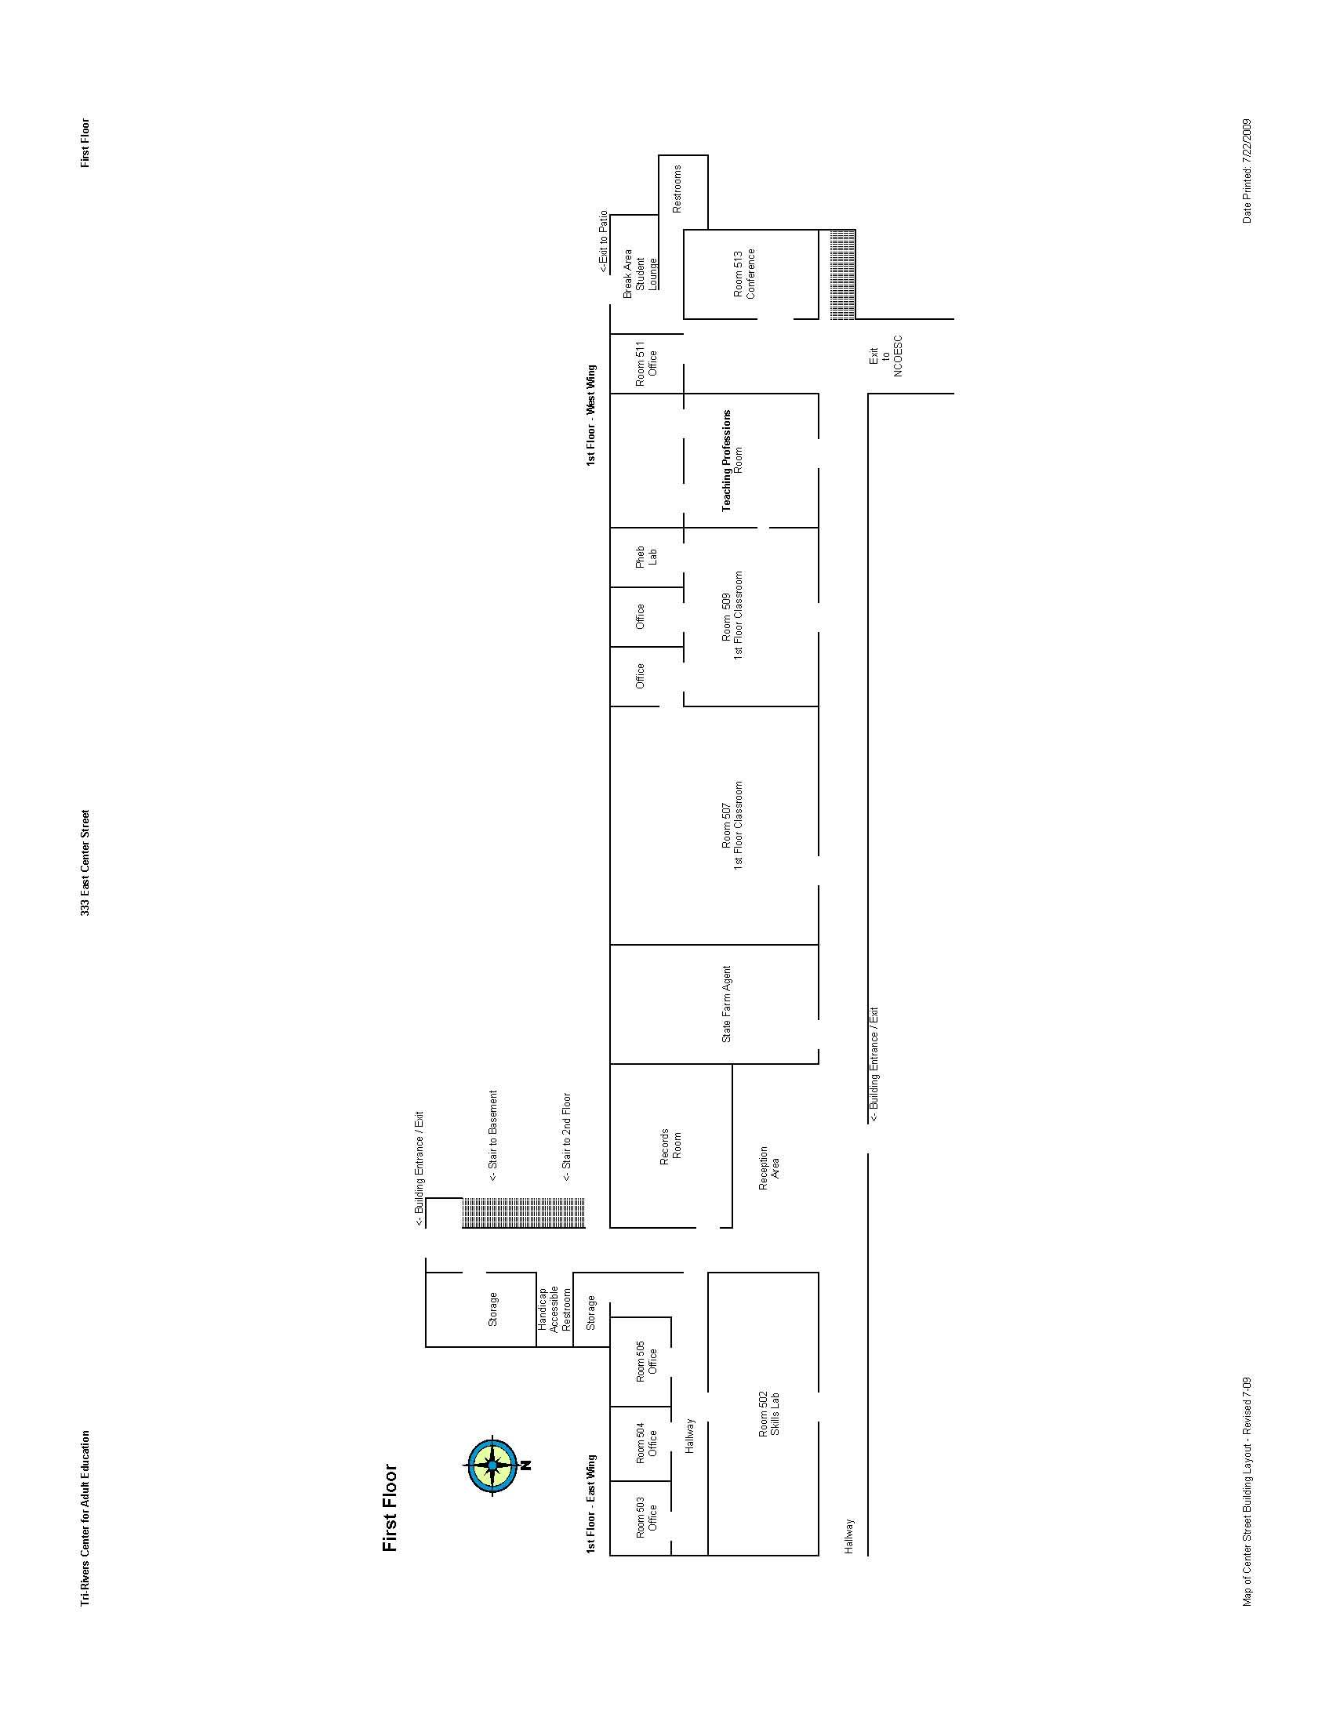
Tri-Rivers Center for Adult Education – 1st Floor
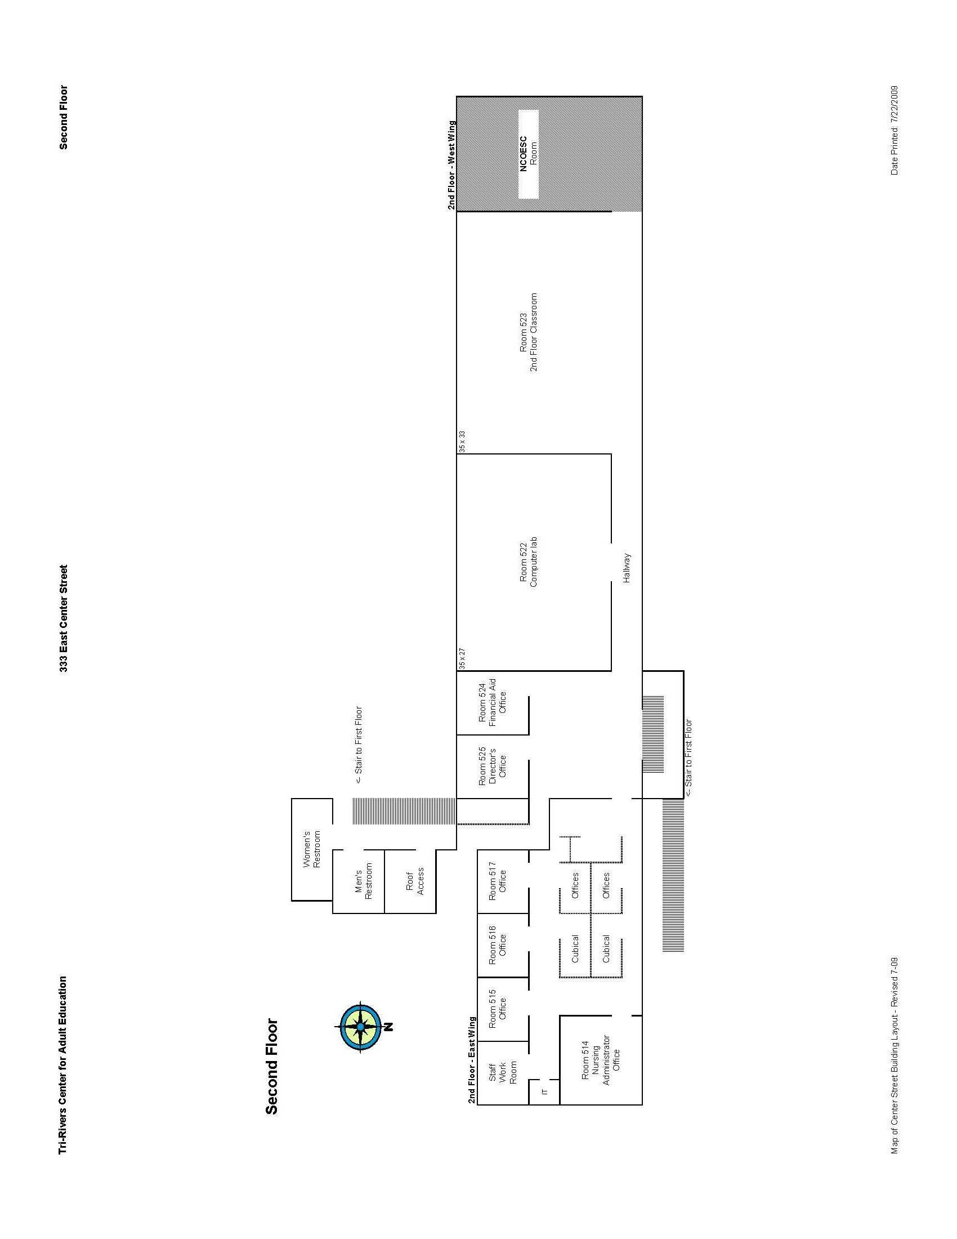
Tri-Rivers Center for Adult Education – 2nd Floor

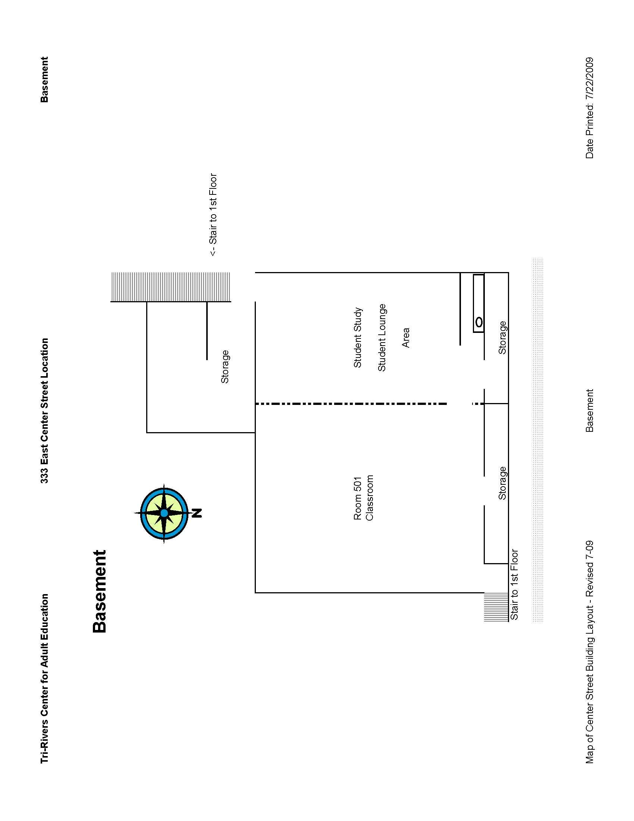
Tri-Rivers Center for Adult Education – Basement

ADULT EDUCATION STAFF LIST

Full-time Staff

Nikki Barnhart – X524
Financial Aid Administrator

Nancy Epley – X505
Executive Assistant

Dee Dee Farmer – 515
Practical Nursing Instructor

Jessica George – X352
Public Safety Services Instructor /
Clinical Coordinator

Richard George – X525
Director

Emeline Kelly – 514
Manager of Nursing Education Programs

Ed Long – X265
Public Safety Services Instructor

Lori McGuire – X517
Patient Care Tecnician /
Pharmacy Tech Coordinator

Amy Pirnstill – X353
Transitions Coord / Voc. Eval /
Job Placement / Job Profiler

Jasmine Rausch – 508
Administrator of LPN to RN Transitions Program

Cynthia Salyer – X516
Practical Nursing Instructor / Nurse Aide Coordinator

Regina Shumaker – X351
Public Safety Services Coordinator

Part-time Staff

Ted Davis
Industrial Maintenance Coordinator / Instructor

Vonnie Dendinger -- X500
Administrative Assistant

Christy Heid
Nursing Instructor

Josette Hildreth – X519
Nursing Instructor

Larry Honaker - 519
Computer Instructor

Brenda Jolley – X503
Nursing Instructor

Michelle Marko – X520
Nursing Instructor

Jeannie Poast - 500
Administrative Assistant

Linda Wing – X521
Nursing Instructor

ASSOCIATE SCHOOL & AREA MILEAGE

 |  |  | Tri-Rivers | Cardington | Elgin | Highland | Mrn. Catholic | Mrn.Harding | Mt. Gilead | North Union | Pleasant | Ridgedale | River Valley
  One Way Round Trip
Tri-Rivers |  |  |  | 14 | 11 | 29 | 1.5 | 2 | 15 | 23 | 8 | 9.5 | 3
Cardington |  |  | 28 |  | 24 | 16 | 13.5 | 17 | 12 | 15 | 16 | 22 | 12.5
Elgin |  |  | 22 | 48 |  | 40 | 10.5 | 10 | 26 | 10 | 12 | 18 | 11
Highland |  |  | 58 | 32 | 80 |  | 29.5 | 30 | 16 | 44 | 31 | 37.5 | 26.5
Marion Catholic |  |  | 3 | 27 | 21 | 59 |  | 2 | 15 | 21 | 6 | 7.5 | 4.5
Marion Harding |  |  | 4 | 34 | 20 | 60 | 4 |  | 18 | 21 | 5 | 8 | 7.5
Mt. Gilead |  |  | 30 | 24 | 52 | 32 | 30 | 36 |  | 35 | 19 | 22.5 | 11.5
North Union |  |  | 46 | 30 | 20 | 83 | 42 | 42 | 70 |  | 13 | 26 | 26.5
Pleasant |  |  | 16 | 32 | 24 | 62 | 12 | 10 | 38 | 26 |  | 10 | 9.5
Ridgedale |  |  | 19 | 44 | 36 | 75 | 15 | 16 | 45 | 52 | 20 |  | 12.5
River Valley |  |  | 6 | 25 | 22 | 53 | 9 | 15 | 23 | 53 | 19 | 25
Round Trip Mileage from Tri-Rivers to: |  |  |  | Columbus (downtown) - 100 |  |  | Eastland JVS - 110 |  |  | Apollo JVS - 110 OSU - 90
 |  |  |  | Ohio High Point JVS - 100 |  |  | Pioneer JVS - 80 |  |  | Delaware JVS - 50
 |  |  |  | Central Ohio JVS - 85 |  |  | EHOVE JVS - 134 |  |  | Rt. 161 & 71 - 80
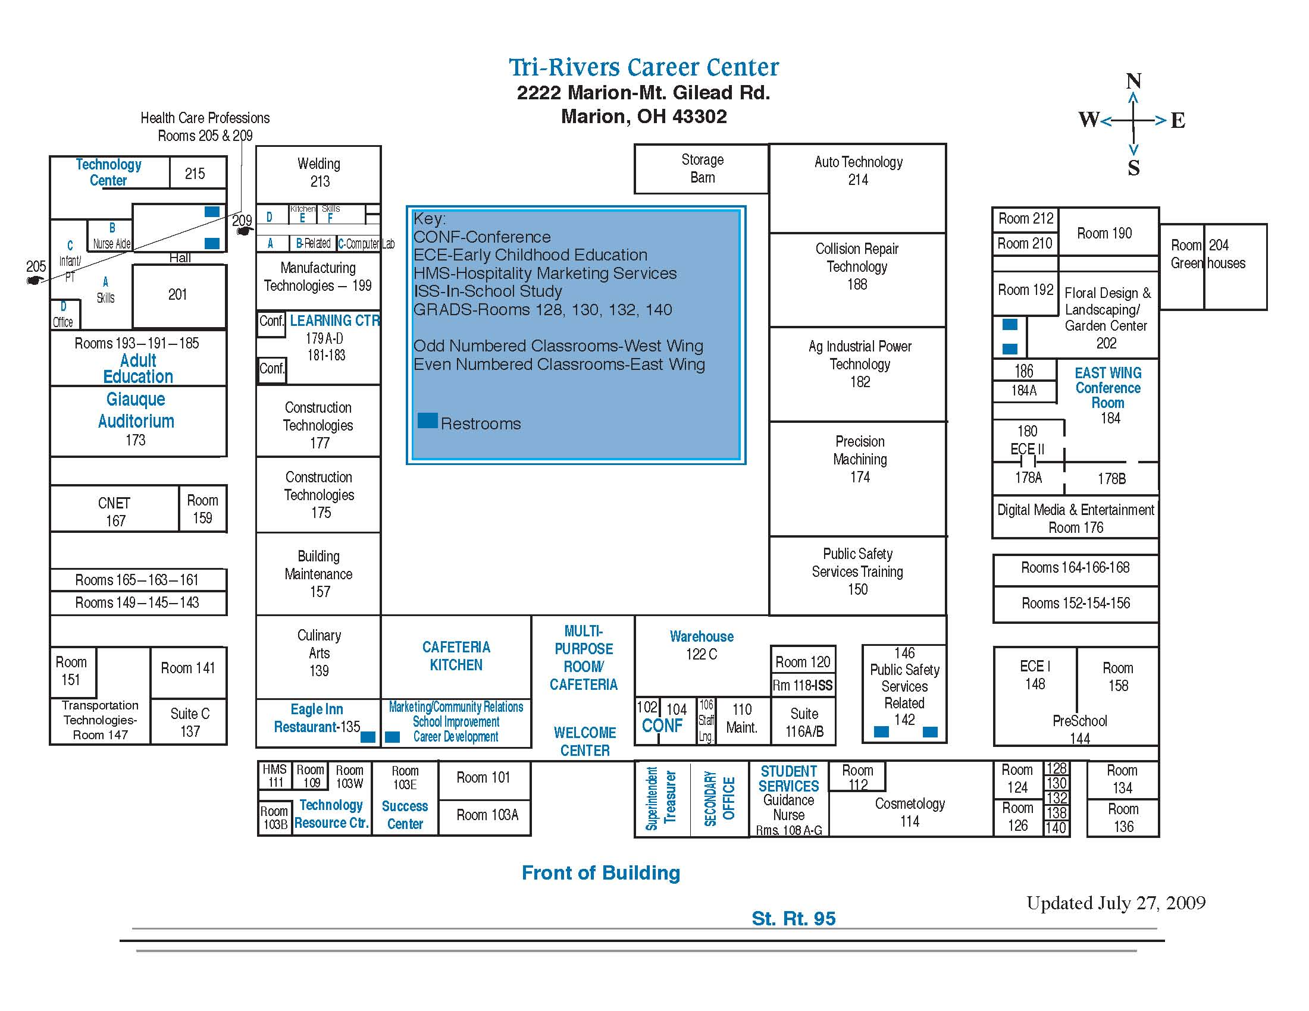
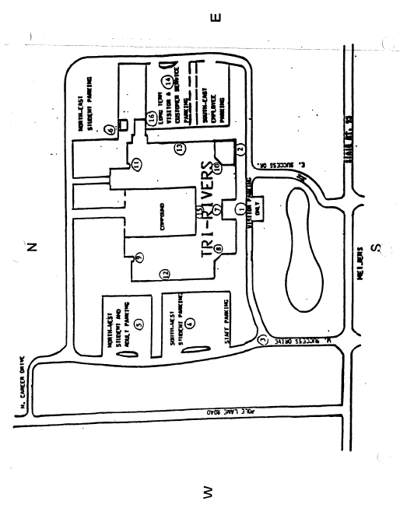

2009-10 TRI-RIVERS COLLEGE TECH PREP SATELLITE PROGRAMS

Tri-Rivers College Tech Prep Programming is a unique curriculum offered to high school Juniors and Seniors that trains students in a high-tech discipline and allows them to earn college credits while still in high school. These college credits will transfer to most colleges. Instructors are outstanding in their fields and will provide a wealth of information and hands-on experience. Ultimately, the Tri-Rivers College Tech Prep programs’ mission is to prepare its students to move on to a two-year college, four-year college, to pursue advanced technical training, or to go directly into the work world. Training in one of the Tri-Rivers College Tech Prep programs offers students a distinct competitive advantage over their peers while staying involved in high school activities. Tri-Rivers Career Center offers the following three programs:

ENGINEERING
at Marion Technical College
Center of Workforce Development Room 111
Level 2—7:50-10:20 a.m. or 12:00-2:30 (3 credits)
Ritch Ramey, Instructor Marion Technical College, 740-389-4636 or
rramey@tririverscc.org for more information

HEALTH TECHNOLOGIES
at Marion Harding High School Room 132-133
Level 2—Lab 7:50-10:20 a.m. (3 credits)
Level 1—11:46-2:30 p.m. (3 credits – 2 credits Health,
1 credit Anatomy & Physiology)
Laurie Wise, Instructor, at Marion Harding, 223-4687 or
lwise@tririverscc.org for more information

TEACHING PROFESSIONS ACADEMY
TRCC Adult Education Center on Center
333 East Center Street
a.m. lab 8:00-10:30 (3 credits)
p.m. lab 12:00-2:30 (3 credits)
Lori Burkhart, Instructor 740-389-4681, ext 530 or 419-563-5581 or
lburkhart@tririverscc.org for more information

Rev. 05/09
TRANSPORTATION TO COLLEGE TECH PREP SATELLITE LABS

College Tech Prep students should check with associate school administration to determine transportation policy to host school. Promptness to school and class is expected. Students are reminded to be safe at all times. Emergencies do occur; a phone call to your instructor is always appreciated.

SCHOOL CALENDAR

Students will follow both their associate school and Tri-Rivers Career Center school calendar.

For example: If a host school College Tech Prep lab has a spring break scheduled, the student will not attend lab. However, if the associate school is open, the student must attend those classes in session. The same applies when the associate school is not in session but the College Tech Prep lab is open. Student must attend lab.

INCLEMENT WEATHER

When an associate school is closed due to inclement weather, students attending a host school lab are not required to attend. If a host school lab is closed due to inclement weather, students should not report for the lab but should report for scheduled classes at their respective associate school. The associate schools have a variety of policies in place for delays from 1 hour, 2 hour and closed for the day.

Possible scenarios:

- A one-hour delay; College Tech Prep host school student should report to a.m. host school one hour later.
- A two-hour delay; College Tech Prep host school student need not report to a.m. host school for the day.

In all cases, the student and/or parent needs to use good judgment. A delay may affect student arrival times for p.m. labs. A phone call by the student to the host school instructor is always the best way to communicate and help to ensure student’s safety. Students will not be sent home if on a fog delay after arriving at satellite. If satellite is closed, students will be sent home.

STUDENT COSTS

Student fees are $50.00 payable to Tri-Rivers. There may be additional program requirements that may have an additional cost.

ATTENDANCE POLICY

Employers list attendance as important as scholastic achievement when hiring students. College Tech Prep instructors will be responsible for daily reporting of attendance to the TRCC attendance secretary to report in ESIS for easy access to both schools’ personnel. College Tech Prep students are responsible to report attendance and provide excuses to the Associate School Attendance Office. A student who accumulates 7 or more unexcused absences during a semester will receive no credit for that semester.

If your son or daughter is accepted, we trust they have selected a technical program they will not only like, but also one in which they can be successful. The College Tech Prep Consortium and the associate schools have agreed on a policy requiring students who have been accepted into College Tech Prep to attend the program for which they were accepted for a minimum of five (5) days. This policy gives the students the chance to fully explore the program in which they are enrolled. A request for withdrawal may be made after the fifth day and prior to the end of the seventh day of class. Requests are made to the associate school guidance counselor. The counselor forwards all requests to Tri-Rivers Career Center Student Services.

Promptness to labs is expected. Five tardies per grading period will drop the student’s grade one letter.

GRADING POLICY

Course syllabi will be given to students at the beginning of each semester. Each semester will have 2 nine-week grading periods and a semester exam. The semester grade will be calculated by doubling the two quarter grades, adding the semester exam grade and dividing the sum by five. Credit is awarded on a semester basis, if the semester grade average is above an “F”.

College Tech Prep grades, both quarterly and interims, will be issued by Tri-Rivers (see attached calendar for specific dates). Students and Parents have access to Tri-Rivers Career Center Progress Book.

The following grade distribution will be used:

100-97 A+ 86-83 B 72-70 C-
96-93 A 82-80 B- 69-67 D+
92-90 A- 79-77 C+ 66-63 D
89-87 B+ 76-73 C 62-60 D-

Promptness to labs is expected. Five tardies per grading period will drop the student’s grade one letter. Associate school will monitor eligibility. Students participating in extra-curricular activities will be required by their associate school to get a signed report from College Tech Prep instructor verifying eligibility. Career-Technical Student Organization activities are considered co-curricular, not extra-curricular. A student who accumulates 7 or more unexcused absences during a semester will receive no credit for that semester.

STUDENT CONDUCT, DRESS, and DISCIPLINE CODE

Students will follow the student conduct, dress/uniform and discipline code for the building in attendance. College Tech Prep student athletes are permitted to wear team attire on game day.

The host school and associate school will monitor discipline and communicate as needed.

Students will follow the Technology Acceptable Use Policies for the associate school and host school.

A copy of the student’s emergency medical form must be forwarded to the College Tech Prep host school instructor. The College Tech Prep instructor will handle field trip requests and permission forms.

OTHER

The associate school and host school will provide modifications and accommodations stated on the IEP based on student’s schedule. Host schools with Tri-Rivers Career Center as the fiscal agent are responsible to invite and include the Tri-Rivers VOSE Coordinators to participate and assist as needed. The associate school will monitor proficiency testing and provide intervention as needed.

Marion Technical Scholarships are available for high school seniors. More information will be shared during student’s senior year.

09/10 Tri-Rivers College Tech Prep Programs

